ASSESSMENT OF A NEXT GENERATION GRAVITY MISSION FOR MONITORING THE VARIATIONS OF EARTH’S GRAVITY FIELD

Issue 1.0

WP3200 Scientific Assessment of the Baseline Mission

Written by | Responsibility
T. van Dam | Author
P.N.A.M. Visser | Author
Verified by
Approved by
Documentation Manager
P.N.A.M. Visser

CHANGE RECORDS
ISSUE | DATE | § CHANGE RECORDS | AUTHOR
1.0 | November 2010 |  | TD,PV

TABLE OF CONTENTS
1. INTRODUCTION 4
1.1 Scope and Purpose 4
2. Documents 4
2.1 Applicable Documents 4
2.2 ESA Reference Documents 4
2.3 Further Reference Documents 4
3. GRAVITY FIELD MISSION SCENARIOS ANALYZED BY the End-to-end simulator 5
4. MISSION PERFORMANCE AND SCIENCE REQUIREMENTS 8
4.1 Comparison with “condensed” science requirements 8
4.2 Comparison with original science requirements 10
5. Conclusions and recommendations 12
6. ACRONYMS 13

INTRODUCTION

Scope and Purpose
This document is submitted in fulfillment of WP 3200 of the Next Generation Gravity Mission (NGGM) study. This document includes a summary of:
- Selection of cases run by the End-to-End simulator (Chapter 3);
- Comparison between performance for these cases with the science requirements (Chapter 4);
- Conclusions and recommendations (Chapter 5).

Documents

Applicable Documents
- Assessment of a Next Generation Gravity Mission to monitor the variations of Earth’s gravity field, Statement of Work, EOP-SF/2008-09-1334, Issue 2, 20 November 2008, Appendix 1 to AO/1-5914/09/NL/CT
- Special Conditions of Tender, Appendix 3 to AO/1-5914/09/NL/CT
- Draft Contract. Appendix 2 to AO/1-5914/09/NL/CT.

ESA Reference Documents
- T. van Dam et al., Monitoring and Modelling Individual Sources of Mass Distribution and Transport in the Earth System by Means of Satellites, Final Report, ESA Contract No. 20403, November 2008

Further Reference Documents
- Study Technical Note “Requirement Analysis”, NGGM_SCI_1, Issue 1, Revision 1, 08-February, 2010
- WP1100 Requirements Analysis, 4 December 2009
- TN3_IAPG: From Science to Sensor requirements, TN3: Observing Techniques and Instrument Concepts, 29 October 2010 (WP2110)
- TN_IAPG: Reprocessing of mass transport data, 29 October 2010 (WP2320)
- WP2330 Backward Module, November 2010
- WP2420 Mission Architecture Definition/Supervision, November 2010

GRAVITY FIELD MISSION SCENARIOS ANALYZED BY the End-to-end simulator
A total of six different tandems and combinations of these six were investigated in detail by the end-to-end simulator. The first five tandems were selected on the basis of analyses conducted with the quick look tools [RD-7] and the sixth tandem on the basis of the end-to-end results themselves [RD-6]. The six associated mission scenarios are:
- In-line formation in polar orbits (“In-line polar”): 32/503 repeat with 4 & 7 day sub-cycles, 75 km baseline;
- In-line formation in Sun-Synchronous Orbits with the inclination 96.8º (“In-line SSO”): 32/503 repeat with 4 & 7 day sub-cycles, 75 km baseline, 6/18 hr local time at equator crossings (dawn-dusk);
- In-line formation in 63º inclination orbits: 31/481 repeat, 75 km baseline;
- Pendulum in polar orbits (“Pendulum – low”): 32/503 repeat with 4- and 7-day sub-cycles, 62/62 km baseline (in-plane/out-of-plane);
- Cartwheel in polar orbits: 32/503 repeat with 4- and 7-day sub-cycles, 100/50 km baseline (along/radial);
- Pendulum in polar orbits (“Pendulum – high”): 30/463 repeat with 7-day sub-cycle, 62/62 km baseline (in-plane/out-of-plane). Please note that in the remainder of this technical note, “high” and “high-altitude” is simply intended to indicate the pendulum formation flying at a higher altitude. In fact, this altitude is still low for a satellite and in fact below 400 km.
In the remainder of this document, it is assumed that the gravity field performance is based purely on low-low Satellite-to-Satellite Tracking (ll-SST) observations. It has been shown that for short retrieval periods (typically below 7 days), the performance might be enhanced by using Satellite Gravity Gradient (SGG) observations as well, but in general the impact of using these observations is quite limited and does not change the relative ranking of the investigated mission scenarios [RD-6]. The gravity field performance in terms of cumulative geoid error for 7-day sub-cycles and full repeat periods is displayed in Figure 1 and Figure 2, respectively (note the linear scale for the vertical axis). The geoid error was computed for the tandems 1-2, 4-6 and for the Bender formation consisting of the tandems 1 and 3 for different spherical harmonic (SH) domains. As concluded in [RD-6], both the low and high altitude pendulum tandem displays the best performance for SH above 20, even better than the dual-tandem Bender formation. The pendulum concept is however more challenging from a technological (e.g. more complicated attitude control) and operational (e.g. more fuel use) point of view. It is important to note that also the slope of the geoid error grows much slower than for the other single tandems, indicating that the pendulum formations will also perform much at spatial scales that are smaller than used in the end-to-end simulations (SH cut-off at degree 80, equivalent to spatial scales of down to 250 km). The slope of the geoid error only increases at a lower rate for the dual-tandem Bender formation.
Based on these results, the dual-tandem Bender formation of in-line formations (smallest technological challenge) and the single-tandem high-altitude pendulum formation might be preferred mission scenarios: apart from the very low SH degrees, the gravity field performance in terms of cumulative geoid error is quite comparable for the low altitude single-tandem pendulum and dual-tandem Bender formations.
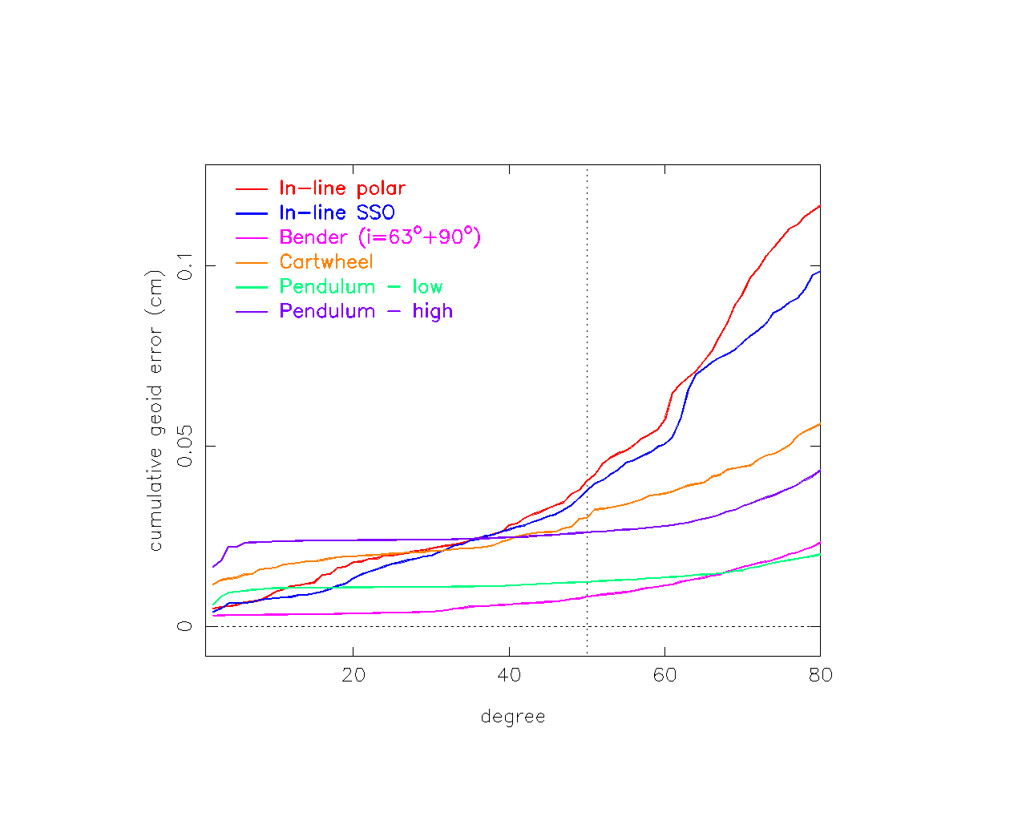 | 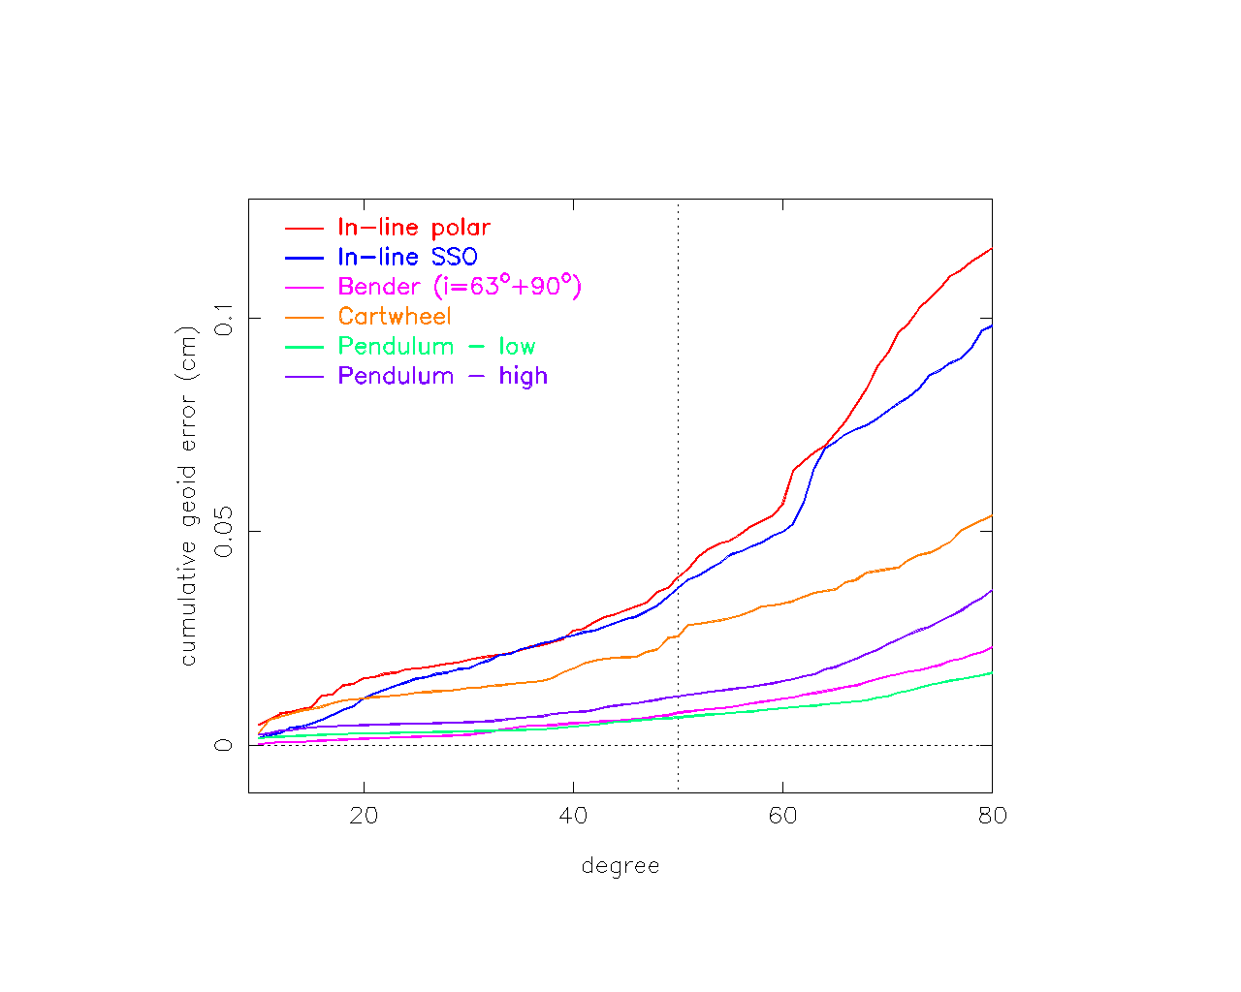
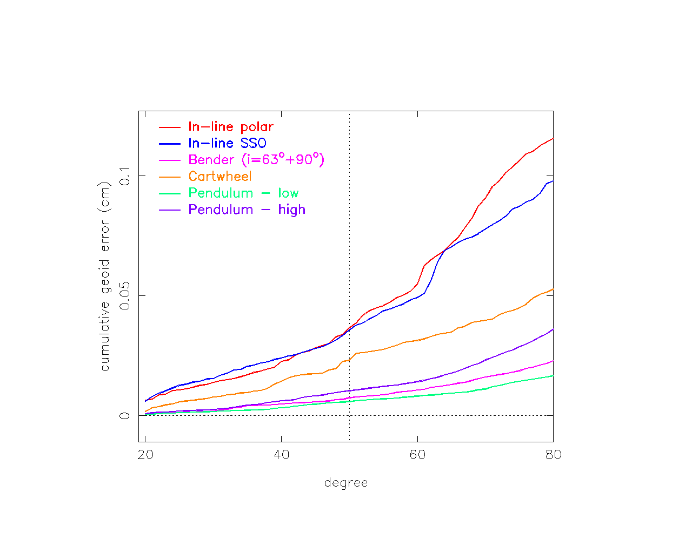 | 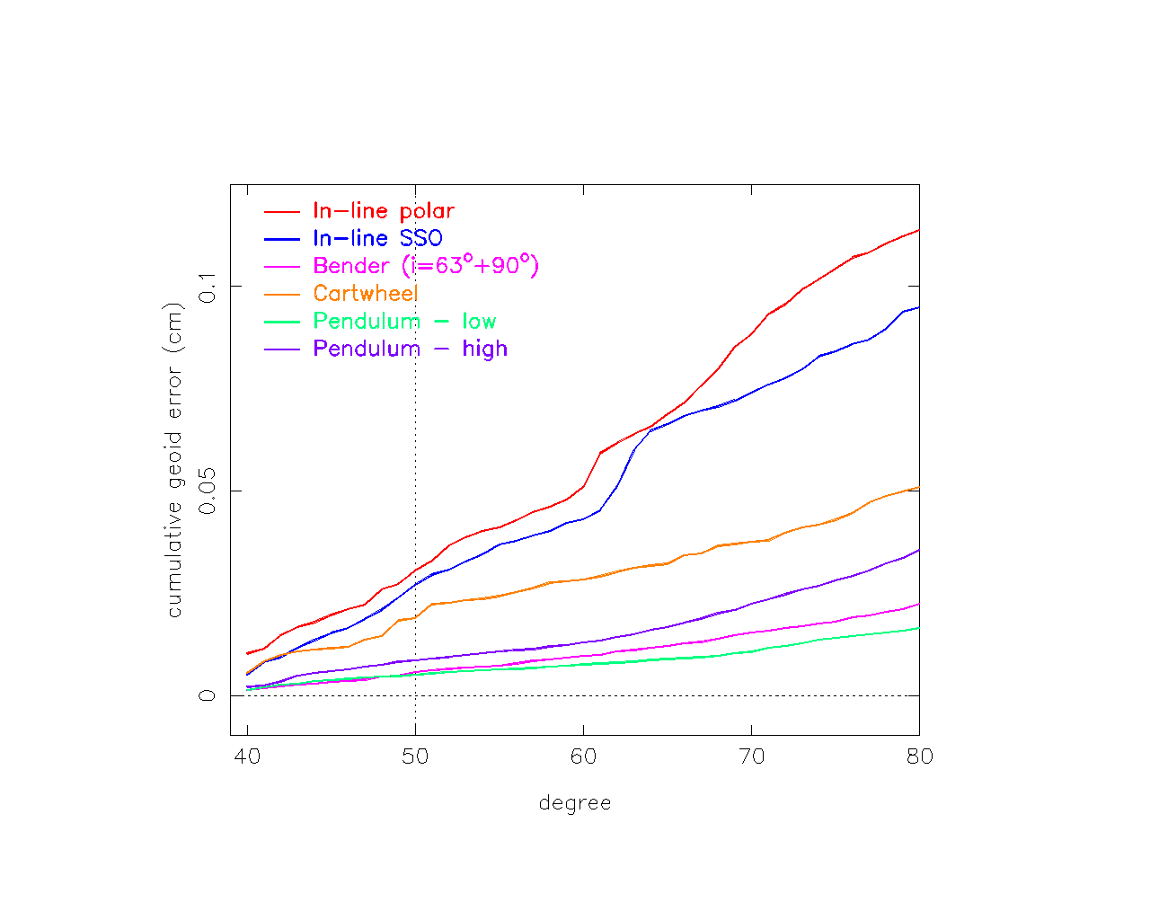
Figure 1 Cumulative geoid error for 7-day gravity field retrievals for several mission scenarios, starting at spherical harmonic degree 2 (top left), 10 (top right), 20 (bottom left) and 40 (bottom right).

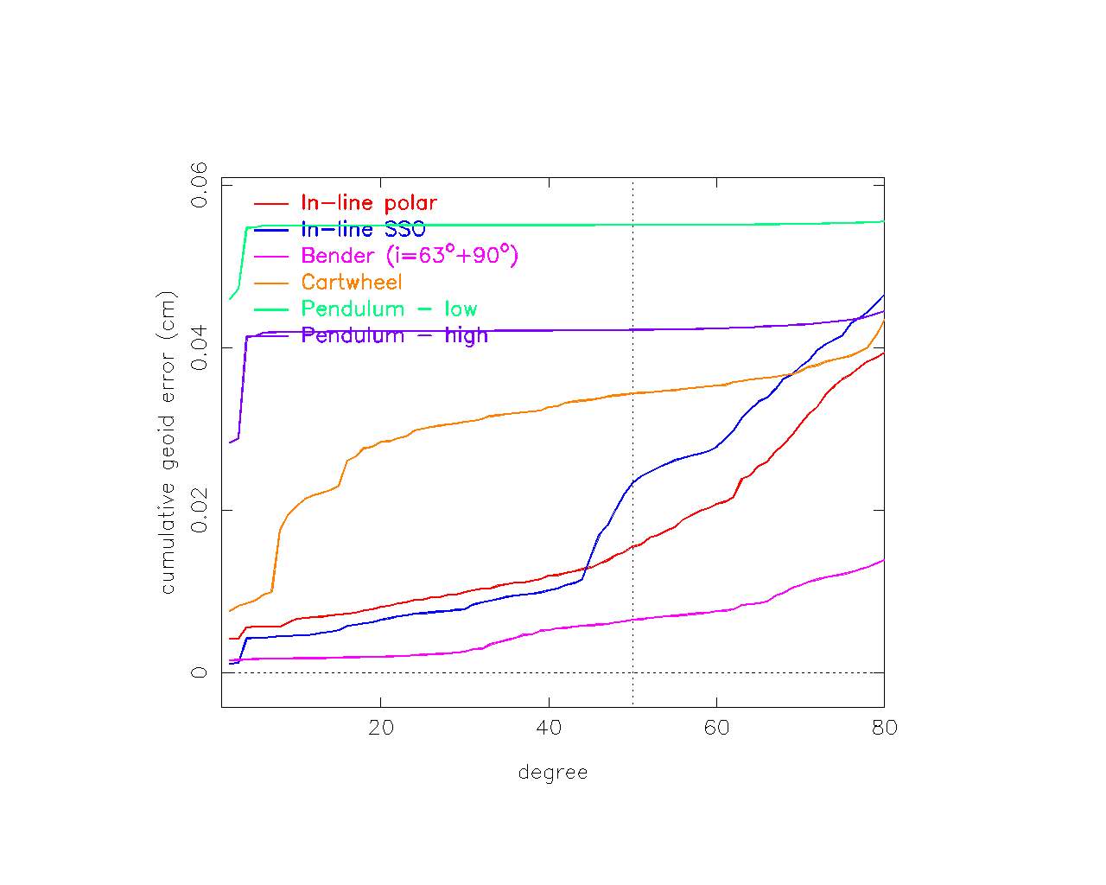 | 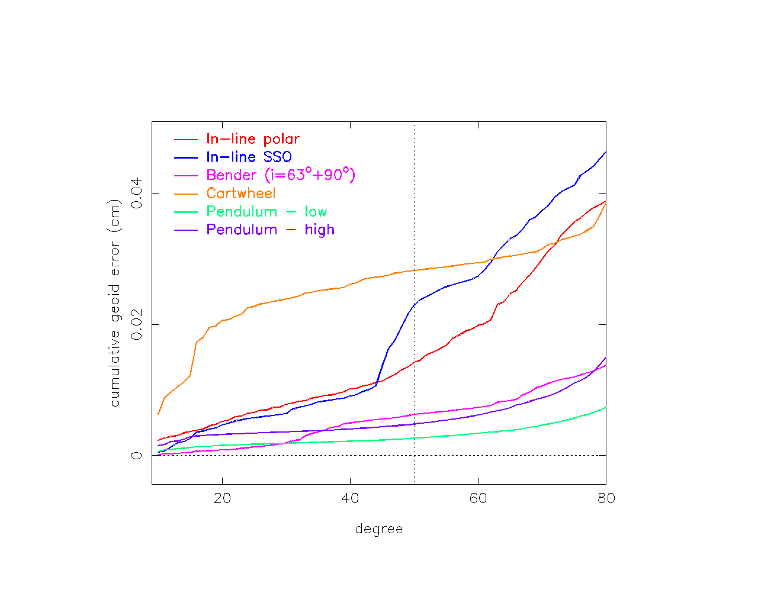
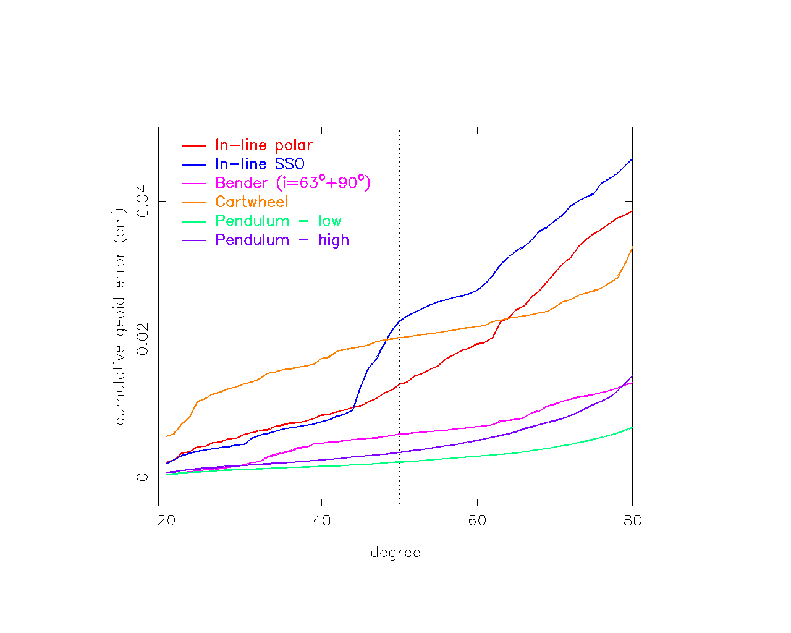 | 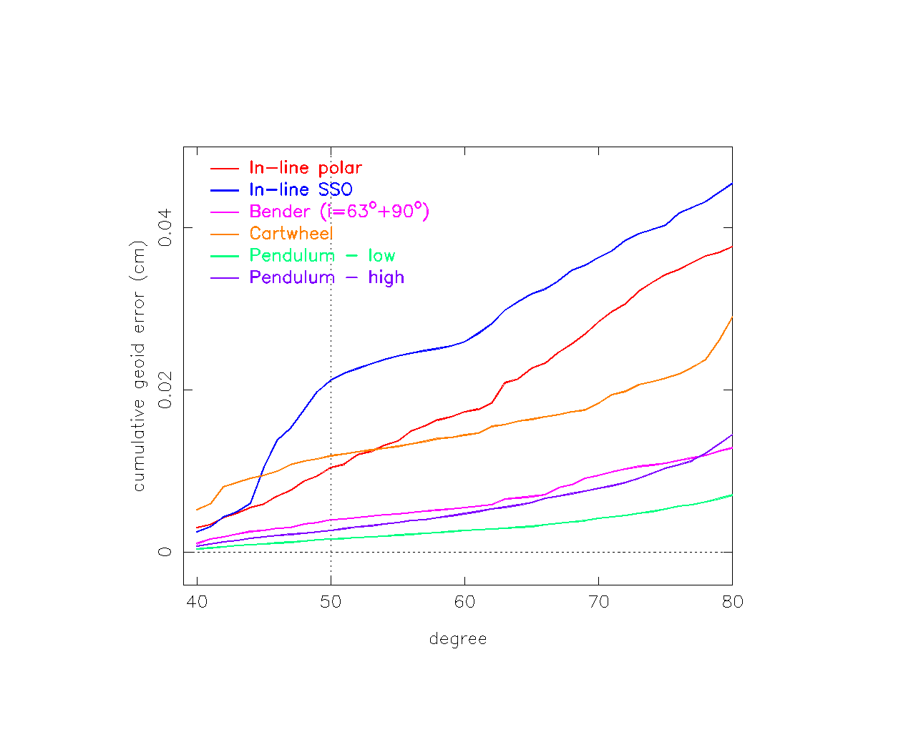
Figure 2 Cumulative geoid error for 32-day gravity field retrievals (30-day for high altitude pendulum) for several mission scenarios, starting at spherical harmonic degree 2 (top left), 10 (top right), 20 (bottom left) and 40 (bottom right).

MISSION PERFORMANCE AND SCIENCE REQUIREMENTS

As a final step, the gravity field performance as estimated for representative mission scenarios has to be compared with science requirements. In Section 4.1, a comparison will be done with the “condensed” requirements as derived in [RD-4]. In Section 4.2, a comparison will be done with the original science objectives identified in [RD-3].

Comparison with “condensed” science requirements

The end-to-end gravity field retrieval experiments were complete to SH degree and order 80 due to the limited time and computing resources available for this study. Thus the smallest spatial scales included have a resolution or half-wavelength of 250 km. In order to close the loop, the end-to-end results need to be compared with the science objectives as formulated in [RD-3] and associated sensor requirements derived in [RD-4]. Spatial scales associated with these objectives go down to below 100 km and a SH expansion complete to degree and order 250. Therefore, a fusion of results obtained by the quick-look tools [RD-7] and end-to-end simulations [RD-6] has been made, where the error curves predicted by the quick-look method has been fitted (“shifted”) or calibrated by the end-to-end simulations. This allows an extrapolation to higher degree and order SH coefficients, in this case complete to degree and order 250. The calibrated curves (“shifted SAS”) are displayed in Error: Reference source not found for the single-tandem in-line polar (“scen1”), in-line SSO (“scen2”) and dual-tandem Bender (“scen1-scen3”) formations. The curve for the Bender formation might be considered as representative for not only this Bender formation, but also indicative for the high-altitude pendulum formation, as stated at the end of Chapter 3.

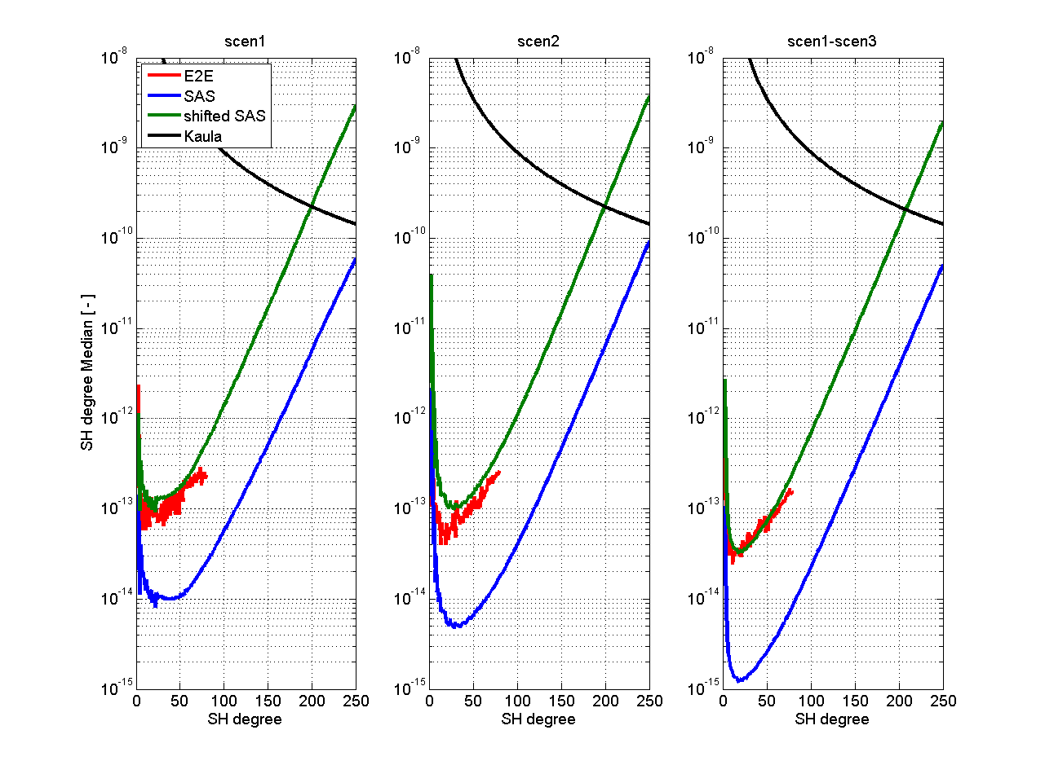
Figure 3 Comparison between gravity field performance estimates using the end-to-end simulator (E2E) and quick-look tools (Semi-Analytical Solution or SAS). A scaled SAS curve that best matches the E2E curve is included as well and extended to degree and order 250. The included mission scenarios are the single-tandem in-line polar (“scen1”) and in-line SSO (“scen2”), and the dual-tandem Bender formation (“scen1-scen3”). The observation period is one full repeat period (about one month).
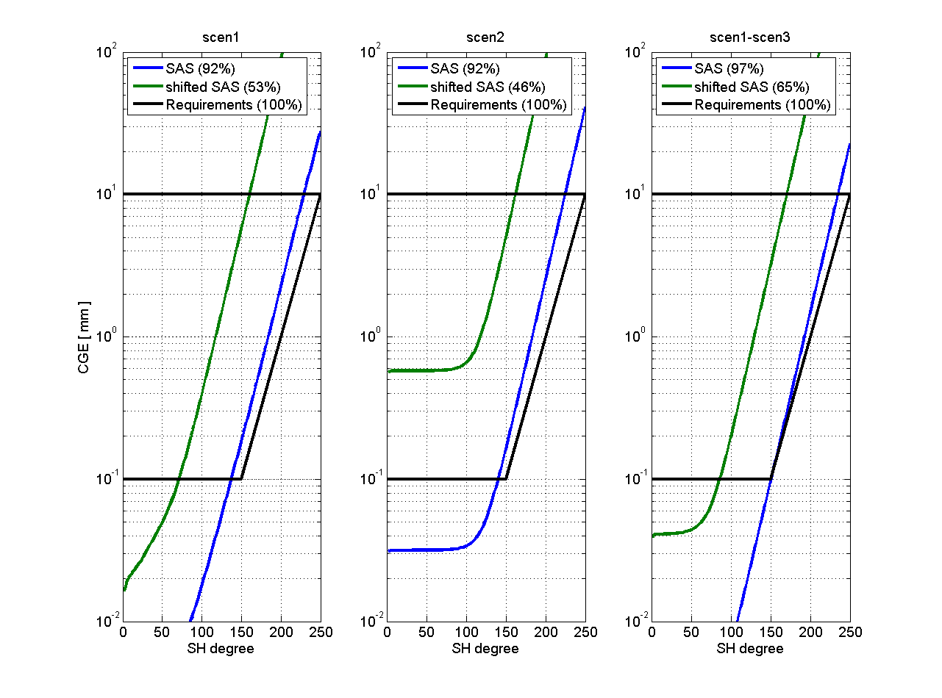
Figure 4 Comparison between the original quick-look (“SAS”) and extrapolated E2E (“shifted SAS” ) gravity field performance and the curves derived from the science requirements. The observation period is one full repeat period (about one month).
The associated gravity field performance in terms of cumulative geoid error (CGE) is displayed in Figure 4, also for the in-line polar (left), in-line SSO (middle) and Bender (right) formations. The numbers between brackets in this Figure reflects the percentage of the science requirements that are met by the associated mission scenario. This percentage is obtained by multiplying the ratio of two areas by 100, the first area encompassed by the green curve and within the thick black lines and the second area is the total area encompassed by these thick black lines. For the single-tandem formations, this percentage is around 50% and for the Bender formation about 65%.

Comparison with original science requirements

Tonie: can you use the results and figures above to make a comparison with Tables 1-4 from the WP1100 technical note? I propose to keep the analysis/comparisons limited to the in-line polar (“scen1”) and Bender (“scen1-scen3”) formations. I think Figure 4 (left and right) can be used to read the CGE and compare with the numbers in Tables 1-4 from WP1100. Preferably this comparison leads to a Table specifying which requirements can be met. Figure 4 above holds for an observation period of 1 month. As a rough rule of thumb, the static CGE for longer periods can be derived by dividing the numbers in Figure 4 by the square root of the number of months, thus for example for a 10 yr period, the numbers would be √120 or 111 smaller.

For linear trends, the following rule-of-thumb can be used:

CGE/yr = CGE(month as in Figure 4)/12√12 = CGE/41

And of course, for the spatial resolution the rule-of-thumb is:

Resolution (km) = 40.000/(cut-off SH degree)/2

Hope this works …

Conclusions and recommendations

Tonie: will you be able to fill in this chapter based on the previous Chapters 3 and 4? Maybe 1 or 2 pages are sufficient?

ACRONYMS

AD Applicable Document
BOL Beginning of Life
BSM Beam Steering Mechanism
C/C Carbon-Carbon (composite)
CGE Cumulative Geoid Error
CHAMP CHAllenging Minisatellite Payload
COM Centre of Mass
E2E End-to-End
EOL End of Life
FF Formation Flying
GNSS Global Navigation Satellite System
GOCE Gravity field and steady-state Ocean Circulation Explorer
GPS Global Positioning System
GRACE Gravity Recovery And Climate Experiment
INRIM Istituto Nazionale di Ricerca Metrologica
ITT Invitation To Tender
KBR K-Band Ranging
LEO Low Earth Orbit
ll-SST low-low Satellite-to-Satellite Tracking
LORF Local Orbital Reference Frame
LRR Laser Retro Reflector
MBW Measurement Bandwidth
MST Mission Simulation Tool
NGGM Next-Generation Gravity Mission
P/L Payload
POD Precise Orbit Determination
PSD Power Spectral Density
RD Reference Document
RF Radio Frequency
RMS Root Mean Square
S/C Spacecraft
SGG Satellite Gravity Gradiometry
SH Spherical Harmonic
SLR Satellite Laser Ranging
SQUID Superconducting Quantum Interference Device
SSO Sun Synchronous Orbit
SST Satellite-to-Satellite Tracking
TAS-I Thales Alenia Space Italia
TBC To Be Confirmed
TBD To Be Defined
END OF DOCUMENT\*

