Assessment of a Next Generation Gravity Mission (NGGM) for monitoring the Variation of the Earth’s Gravity Field

ESA Contract 22643/09/NL/AF

TN_IAPG: Reprocessing of mass transport data

Doc. No.: NGGM_SCI_TN_MASS_TRANSPORT_IAPG
Issue: 1
Revision: 0
Date: 29 October 2010

Author:

Michael Murböck
IAPG, Institut für Astronomische und Physikalische Geodäsie, TU München
murboeck@bv.tum.de

Table of Contents

1 Detection of problems 3
2 Hydrology 3
3 Ice 4
4 Global grids 6
5 Spherical harmonic coefficients 7

1 Detection of problems

The whole data set contains six hourly time series over twelve years (1995-2006) of mass variations for different data types. These are atmosphere ocean hydrology ice and Solid-Earth. If one looks at the global mean time series of each data type, unrealistic behaviours can be seen. There are discontinuities in the first and the last year in the ocean and hydrology data (a small jump can be seen at the beginning of 2001 in the hydrology data as well, see Figure 1). They come from changes in incoming models. The trend in the hydrology data compared to the others is about two magnitudes larger (See Figure 1) and the trend of Greenland ice is positive, which is also unrealistic.
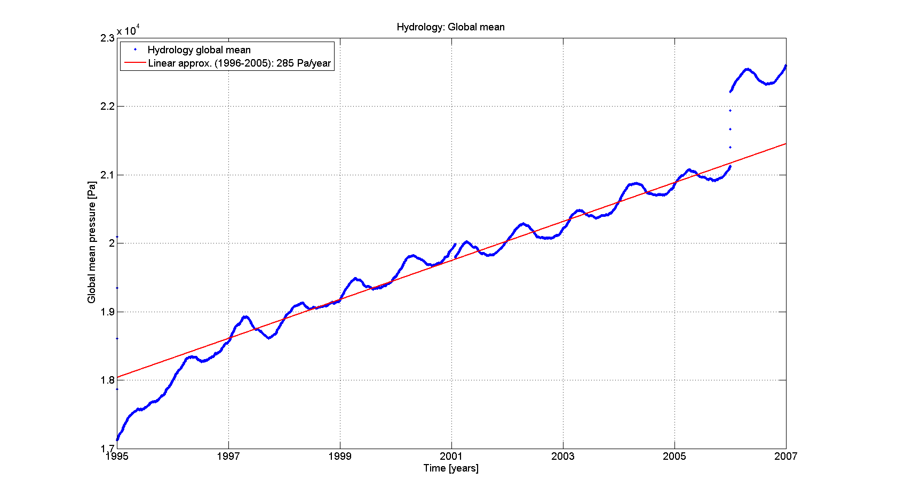
Figure 1: Global mean pressure of hydrology
The trend of the other data sets is in the order of a few Pa/year

2 Hydrology

There are several grid points, which have a huge linear trend and this produces the large global mean trend. These unrealistic trends in terrestrial water storage are due to a build-up of water in inland water bodies such as Lake Titicaca and the Caspian Sea. This is caused by an under-estimation of the local open-water evaporation from the meteorological forcing.
In Figure 2 the spatial and numerical distribution of the linear trend can be seen. It is clear, that these values in the red areas cause the large global mean trend. By cutting points, which reach a specific threshold, one could reduce the global mean trend and make the whole time series more realistic. The here chosen threshold is about three times the standard deviation of the linear trend distribution. Each grid point is deleted, which has a larger absolute value of its linear trend than . The white areas in Figure 2 then contain the remaining points.
The second cutting concerns whole Greenland. The mean trend of simulated Greenland is about . The main mass variations over Greenland depend on the variations of ice masses. Therefore and because of the unrealistic mean trend Greenland is cut from the hydrology data but of course it remains in the ice mass data (See chapter 3).
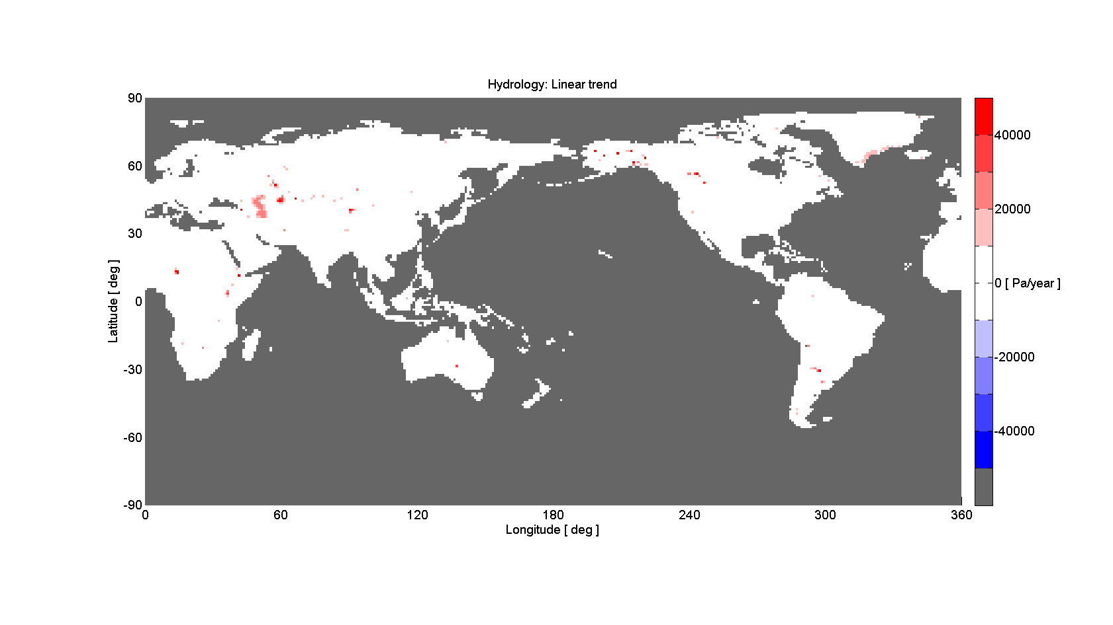
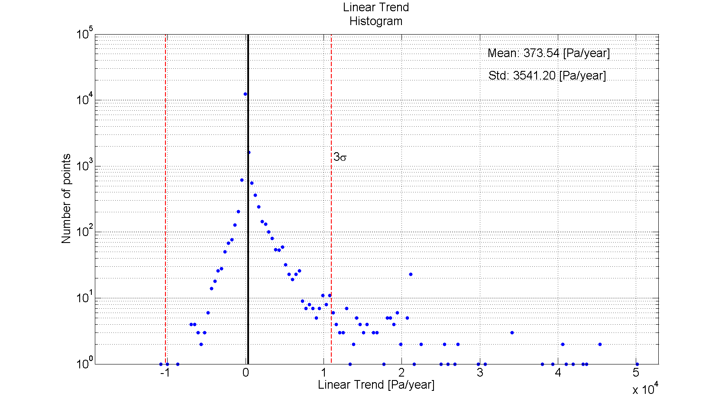
Figure 2: Linear trend of hydrology, top: spatial distribution, bottom: histogram

By cutting all these points (threshold and Greenland) the global mean hydrology trend is reduced from to . In total 894 from 17306 grid points are deleted (5 %) and Greenland contains 772 of them.
The resulting hydrology grid data has a reduced global mean trend. But nevertheless this trend is still large compared to the other fields, e.g. atmosphere . This is an empirical approach only to reduce the trend. Other things could be discussed to make this hydrology data set more realistic.

3 Ice

The original ice data set is given in daily changes separate for Antarctica (AA) and Greenland (GL). The coordinates are stereographic polar on a grid and the unit is mm water equivalent. So the processing must follow the following steps. A transformation to global spherical coordinates is needed. Then for each block a mean value is computed resulting in block mean values (BMV) in mm water equivalent. The following relation converts the water equivalent w.e. in mm to pressure p in using a constant water density d of and a constant gravity g of :
This leads to BMV of daily pressure changes on a grid. By summing up these daily changes one gets the total pressure change with respect to the initial epoch. The temporal resolution of the original data is one day. Linear interpolation then leads to six hourly data. The mean over the whole areas (AA and GL) then is compared before and after the conversion and can be seen in Figure 3.

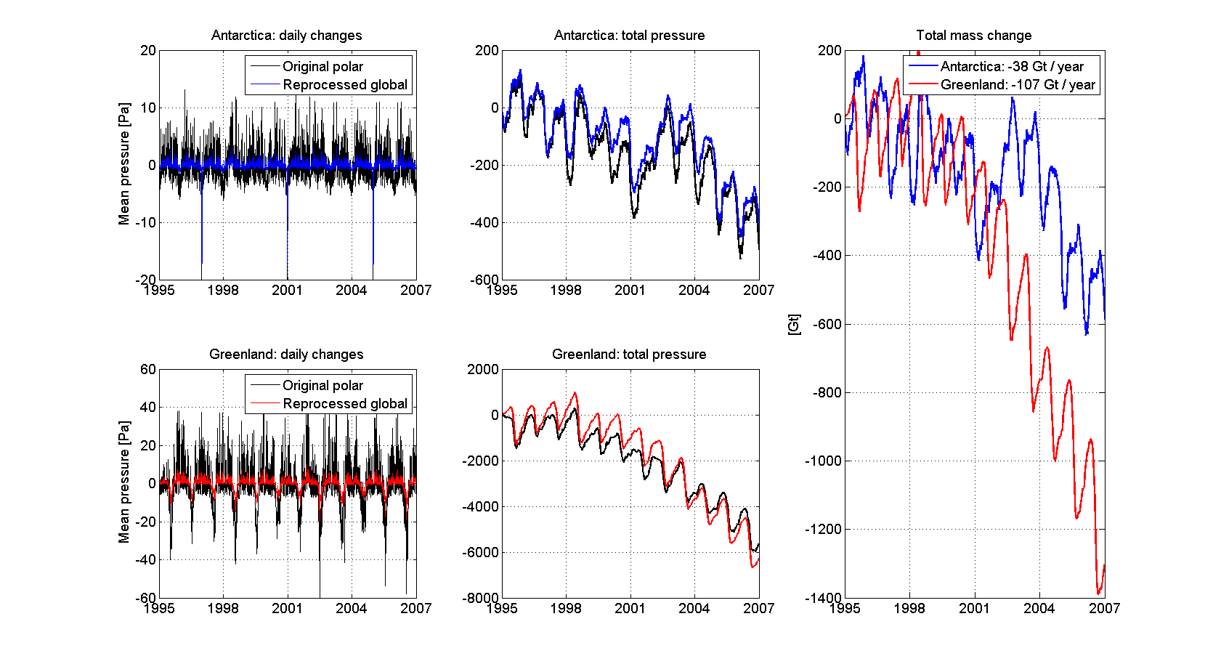
Figure 3: Mean pressure and mean mass of ice transport data. Comparisons of original data (black) and reprocessed grid data (AA: blue, GL: red)

The main problem of the previous version is an increasing ice mass over GL. This is corrected (Figure 3, right, red). Building BMV of the original polar grid data of course is a smoothing process. This smoothing can be seen in the two left images of Figure 3. The lower frequency signal contents stay and therefore the trend in the total pressure and the big annual signal is nearly the same. This leads to mass losses over GL of around 100 Gt per year and around 40 Gt per year for AA. The total mass m in Gt is computed by converting the total pressure p in Pa to mass units:
, where a is the area and is derived from the number of polar coordinate cells of 25 km² each.

4 Global grids

The reprocessed grid files build together a 12 year time series with a temporal resolution of six hours. The spatial resolution is . One can take e.g. hydrology and ice and display the linear trend of each grid cell over a time period (See Figure 4).

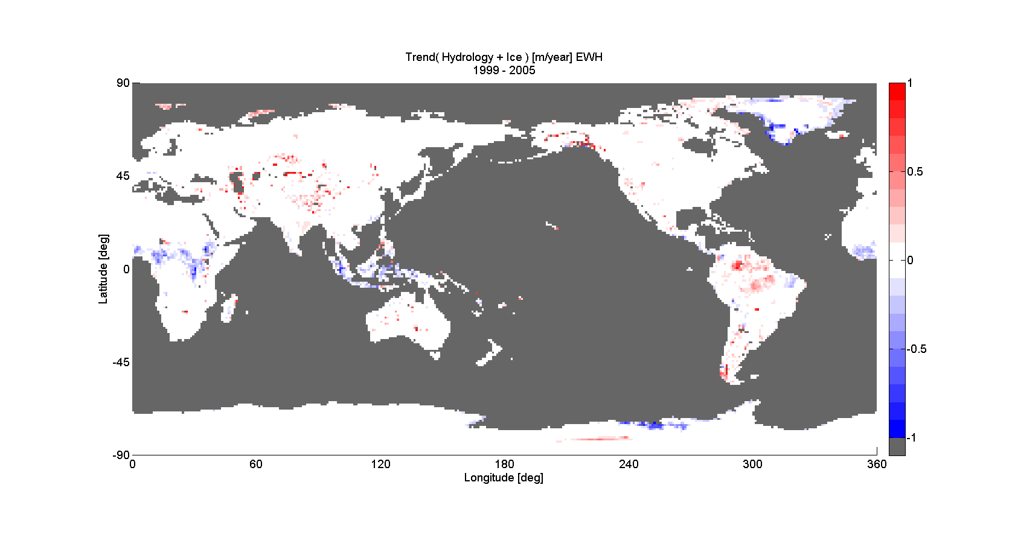
Figure 4: Trend of hydrology and ice for the time period 1999 – 2005 in m/year w.e.

If one subtracts the trend the variability can be calculated by building the RMS value over the time series of each grid cell (See Figure 5).

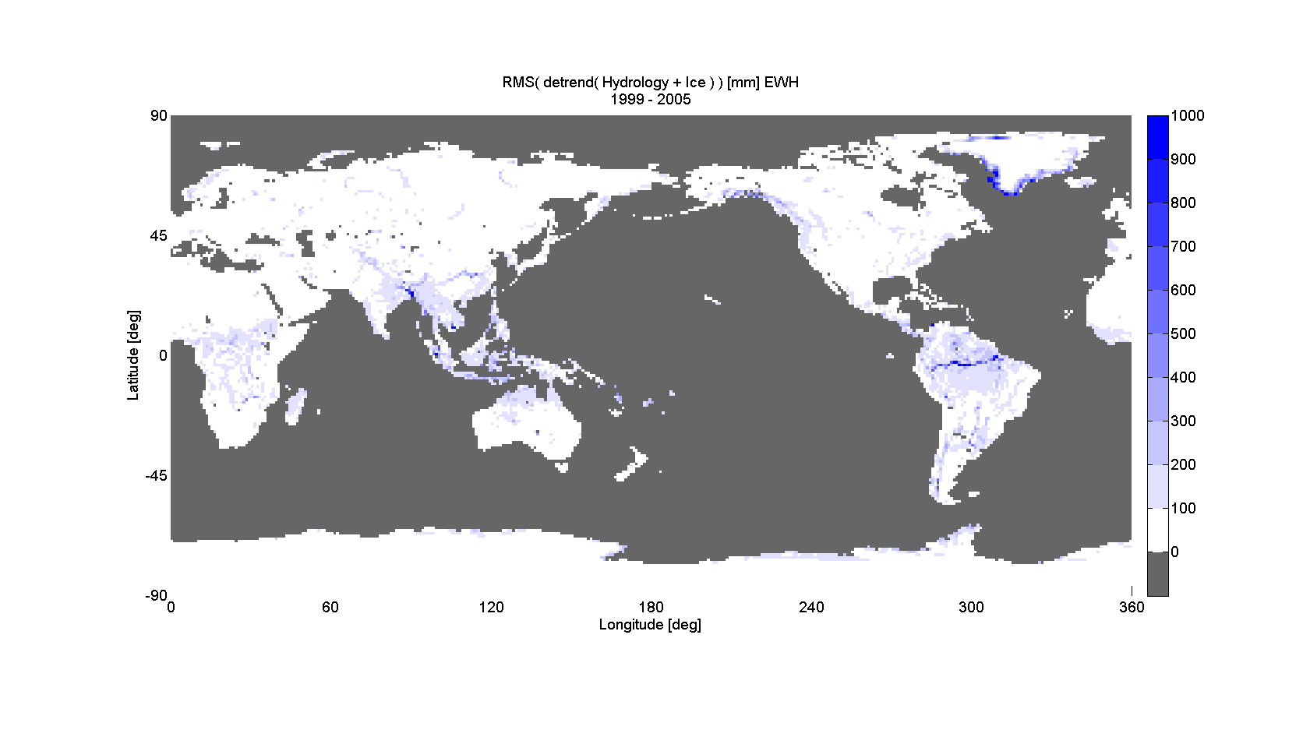
Figure 5: RMS variability of hydrology and ice in mm w.e.

5 Spherical harmonic coefficients

The reprocessed grid data for hydrology and ice then are the input for the spherical harmonic (SH) analysis to estimate SH coefficients containing the mass transport data of the global grid fields. Sequences are calculated starting with atmosphere A alone and then adding the other data types (AO: atmosphere plus ocean, AOH: AO + hydrology, AOHI: AOH + ice, AOHIS: AOHI + Solid-Earth). Therefore SH coefficients for the sequences AOH, AOHI and AOHIS are reprocessed containing the reprocessed grid data H and I. Fully normalized SH coefficients are stored in ICGEM format for each epoch up to degree and order 180. The filenames of the reprocessed SH coefficient files are formatted like shs_seq_yyyymmdd_hh.180 with . The data of every year and sequence is put together in one *.tar.gz file and marked with a version number. In the README.txt the processing history with version numbers is listed.

