Assessment of a Next Generation Gravity Mission (NGGM) for monitoring the Variation of the Earth’s Gravity Field

ESA Contract 22643/09/NL/AF

TN3_IAPG: From Science to Sensor requirements
TN3: Observing Techniques and Instrument Concepts

Doc. No.: NGGM_SCI_TN3_IAPG
Issue: 1
Revision: 0
Date: 29 October 2010

Author:

Michael Murböck
IAPG, Institut für Astronomische und Physikalische Geodäsie, TU München
murboeck@bv.tum.de

Table of Contents

1 Abstract 3
2 Prioritization 3
3 Nominal Mission Profile Requirements 4
4 Simulations 5
4.1 Initial error scenarios 6
4.1.1 Distance measurements between two satellites (SST) 6
4.1.2 Acceleration measurements (ACC) 9
4.1.3 GNSS 12
4.1.4 Gradiometry 13
4.2 NGGM reference error scenario 14
4.2.1 Combination of SST and ACC 14
4.2.2 Gradiometry 16
5 Summary 21
5.1 Initial error scenario 21
5.2 NGGM reference error scenario 23
6 Appendix 25
Appendix A: Error propagation for linear trend estimation 25
Appendix B: Simulation results 26
7 References 32

1 Abstract

This document is submitted with the intent of clarifying the science requirements for a NGGM. The first step is the synthesis of information, which are defined in two documents according to WP1100, which have been submitted to ESA as part of this study. These documents are the WP1100 Report and the WP1100 Requirements Analysis Progress Report (see References 1. and 2.).
The first step is the clarification of prioritizations in terms of spatial and temporal coverage and the scales of the signals, which should be observed by the NGGM. A more difficult but necessary task will be the description of the magnitudes of these signals in terms of geoid heights, gravity potential and equivalent water heights (EWH). It is clear, that these values depend on the spatial and temporal resolution as defined by the mission but also on the location. These magnitudes directly produce a maximum tolerance for the cumulative errors of a NGGM gravity field solution. Thus, with several simulations one can define observation requirements. The requirements represent a description of noise power spectral densities (PSDs) of the distance measurements (SST) in terms of range rate or range acceleration and of accelerometer (ACC) noise. The contributions of GNSS and gradiometer observations to such a mission are discussed in a further section.
It is clear, that there are several other error sources, which will also affect the gravity field solution. The point of this document however, is to evaluate only the signal magnitudes, signal resolutions and the resulting sensor noise structure.

2 Prioritization

Chapter 8 of the WP1100 Report describes four fields of primary focus for an NGGM. These are ice, continental water, ocean masses and solid-Earth. The Table in Chapter 8.6 of the document provides a rated list of different signals. The four highest rated signals are listed below in Table 2. Their different attributes, i.e. signal magnitude at a particular temporal scale, are taken from the documents referred to above. The table lists only the signals of interest to the NGGM. The numbers presented in the table, represent approximate magnitudes, which we use to derive the observation requirements. The numbers in the table are only given in terms of geoid heights. Using the values in Table 1 one can derive EWHs or gravity potential for these five SH degrees. The conversion to gravity anomalies or EWHs from the other two units is frequency dependent.

 | SH degree
 | 50 | 100 | 150 | 200 | 250
 | 0.01
 | 1
 | 69 | 129 | 189 | 249 | 309
Table 1: SH degree dependend translation of gravity signal magnitudes to different functionals (values for EWHs: personal communication with Isabelle Panet)

 | Description | Spatial  resolution | Temporal  resolution | Signal magnitude  in geoid heights
1 | Melting of ice sheets (with separation of GIA) | 100 – 1000 km | Seasonal –  secular | - mm/year (secular)
2 | Non-steric comp. of sea-level var. at seasonal and shorter time scales | Global to basin level | Interannual –  secular | 0.1 mm/year (secular)
3 | Ground water (soil moisture and snow) at  larger spatial scales | 10 – 200 km | Hourly –  seasonal –  secular | 1 cm (seasonal)
4 | Post-seismic deformation | 10 – 200 km | Subseasonal | 1 mm (subseasonal)
Table 2: Fields of Prioritization with their spatial and temporal resolution and approximate signal magnitudes (see References 1. and 2.)

3 Nominal Mission Profile Requirements

Before defining observation requirements one must define a nominal mission profile. The scientific requirements demonstrate that it is not very important to reach a temporal resolution shorter than 1 month. Of course a NGGM with improvements in monthly data with a subcycle of a few days will also provide interesting information for these time scales. Another benefit would be reduction of temporal aliasing.
The nominal repeat cycle will be 30 days and the nominal mission life time 11 years (long term trends, solar cycle). And because of societal and scientific priorities for observing the polar regions (ice masses) an inclination of close to 90 degrees will be part of the nominal profile.
The next step is the translation of the numbers in Table 2 into maximum cumulative geoid errors (CGE) for the nominal mission. Therefore the desired secular signal magnitudes of ice mass variations (1) and sea-level variations (2) are translated into monthly values. For that purpose, values ten times larger for the monthly measurements (0.1 mm for 1 and 1 mm for 2) is sufficient (See Appendix A).
A wavelength λ in km can be approximately transformed into SH degree L with .
With these assumptions one can derive the following Table 3 of requirements for the monthly gravity field in terms of maximum CGE.

 | Wavelength | 10000 km | 1000 km | 200 km | 100 km |  | 10 km
 | SH degree | 2 | 20 | 100 | 200 |  | 2000
CGE | 10 mm |  |  | 3
CGE | 1 mm | 2 |  |  | 4
CGE | 0.1 mm |  | 1
Table 3: Requirements in terms of max. CGE for monthly solutions (The numbers in the grey boxes correspond to the first column of Table 2), the shaded areas on the right mark the restriction to more realistic values in case of a monthly satellite gravity field
The next step is a restriction of the values in Table 3 to more realistic requirements for the CGE of the gravity field solution of a NGGM. Therefore the three boxes (3, 4 and 1) will be reduced to smaller SH degrees (shaded areas). In any case, a compromise is required to get to the values in Table 4. On a monthly basis it is far beyond observation techniques from space to require a 0.1 mm geoid up to SH degree 200 or a 1 cm geoid up to SH degree 2000. In this case, a first step of iteration could be the following values for CGEs. The NGGM should provide gravity information up to SH degree 250 and the cumulative geoid error for the SH degrees 150, 200 and 250 should be not greater than 0.1, 1 and 10 mm respectively. From this point of view the signals in Table 2 will be observable to a large extent in spatial resolution and with a temporal resolution of one month.

SH degree | 150 | 200 | 250
CGE [mm] | 0.1 | 1 | 10
Table 4: Requirements for CGE

4 Simulations

From these requirements, semi-analytical simulations for different sensor systems can be performed to investigate, how much of the requirements can be fulfilled with which noise PSD. By propagating observation noise in terms of noise PSDs, these simulations estimate variance-covariance matrices of SH coefficients. As this exercise represents only error propagation, it is clear that this approach cannot take aliasing and other analysis technique problems into account. In the following chapters, simulation results are presented in terms of CGE. These are global mean values. For any mission, the error distribution will mainly depend on the latitude. For polar missions, the lowest errors will be at the poles. For non-polar orbits, the errors will increase dramatically for latitudes without observations.
The figures we present contain results of simulations for nominal distances between the satellites, km, and different mission altitudes km. The simulations are computed up to SH degree and order 250. The strategy starts with defining error models for the different sensors. The sensor requirements then are the maximum level up to which these models can be shifted to meet the requirements in Table 4. The simulations start with initial error models in chapter 4.1 and in 4.2 sensor requirements are derived for the NGGM reference error scenarios.

4.1 Initial error scenarios

4.1.1 Distance measurements between two satellites (SST)
White noise
Range rate observations are taken as measurements. White noise is assumed for the noise of the range observations. In terms of range rate, this represents a noise increasing with the frequency (see dashed lines in Figure 1). The PSD can be written as in (a in Hz^{-0.5} and d in m), where d is the distance between the two satellites and a is chosen from with .

Coloured noise
Again range rate observations are taken as measurements. A typical noise PSD for such an observation looks like the solid lines in Figure 1 and can be computed from
for in , where d is distance and a is the white noise level for high frequencies. The values used for a are the same as for the white noise case. The image on the left of Figure 1 shows the PSDs in terms of range observations as described in the formula. The image on the right shows the PSD in terms of range rate observations (Multiplication with ). The definitions of these PSD functions can also be found in the document presented by ThalesAlenia at the first Progress Meeting in Turin (See references 3.).

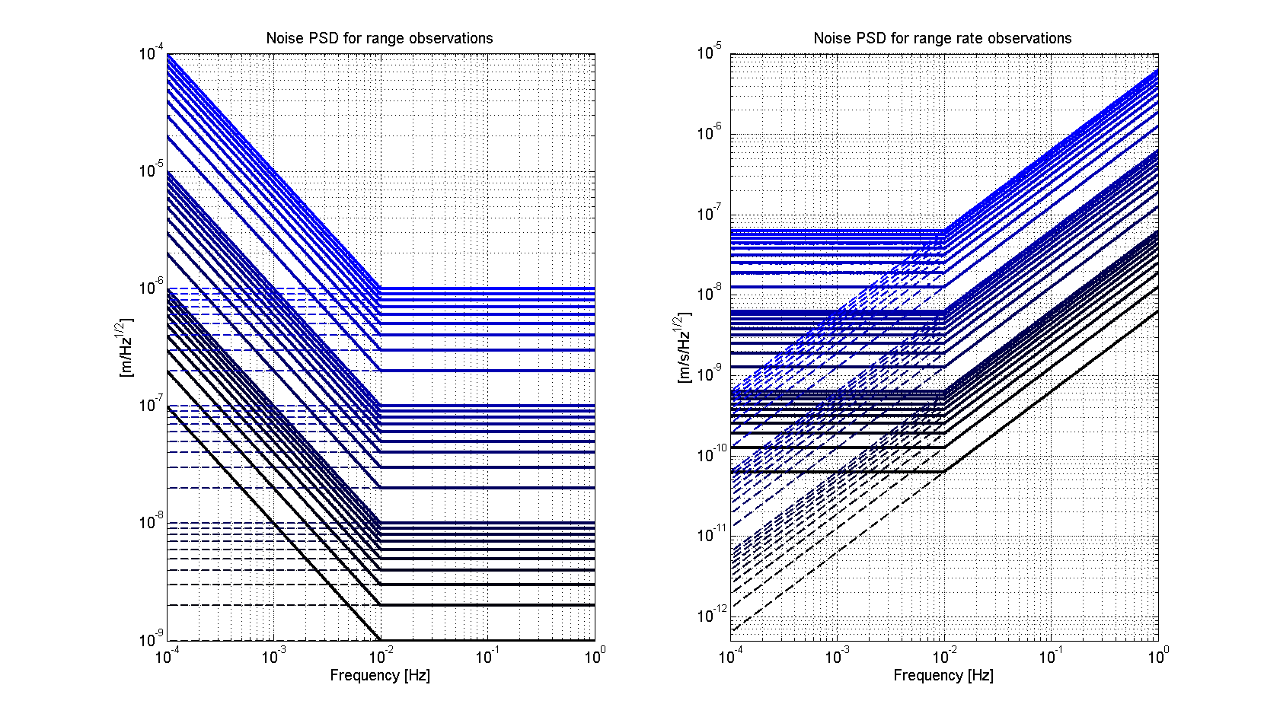
Figure 1: Noise PSD in terms of range and range rate observations for the SST sensor system for the distance between the satellites of 100 km (solid lines: coloured noise, dashed lines: white noise, red lines: Previous NGGM study limit, see references 5.)

Simulation results
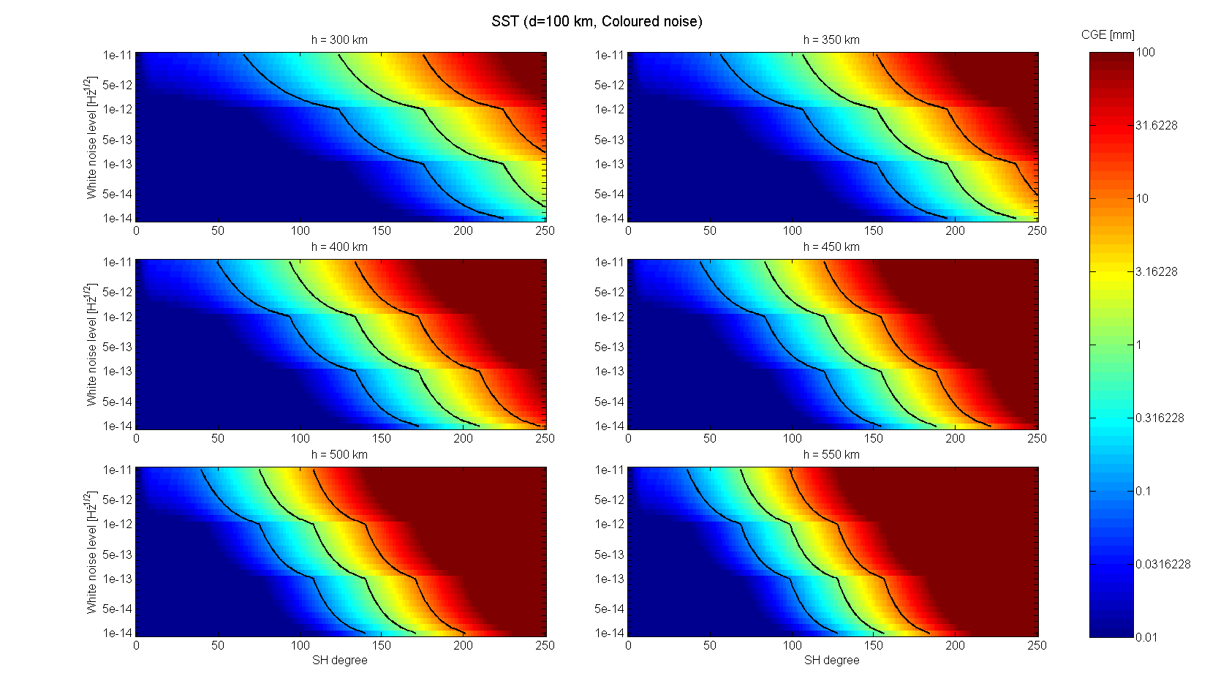
Figure 2: Cumulative Geoid Error for the SST sensor system for d=100 km, coloured noise case (the three black lines in each plot represent the CGE levels 0.1, 1 and 10 mm), the x axis is equal to the value a in the analytical descriptions of the noise PSDs

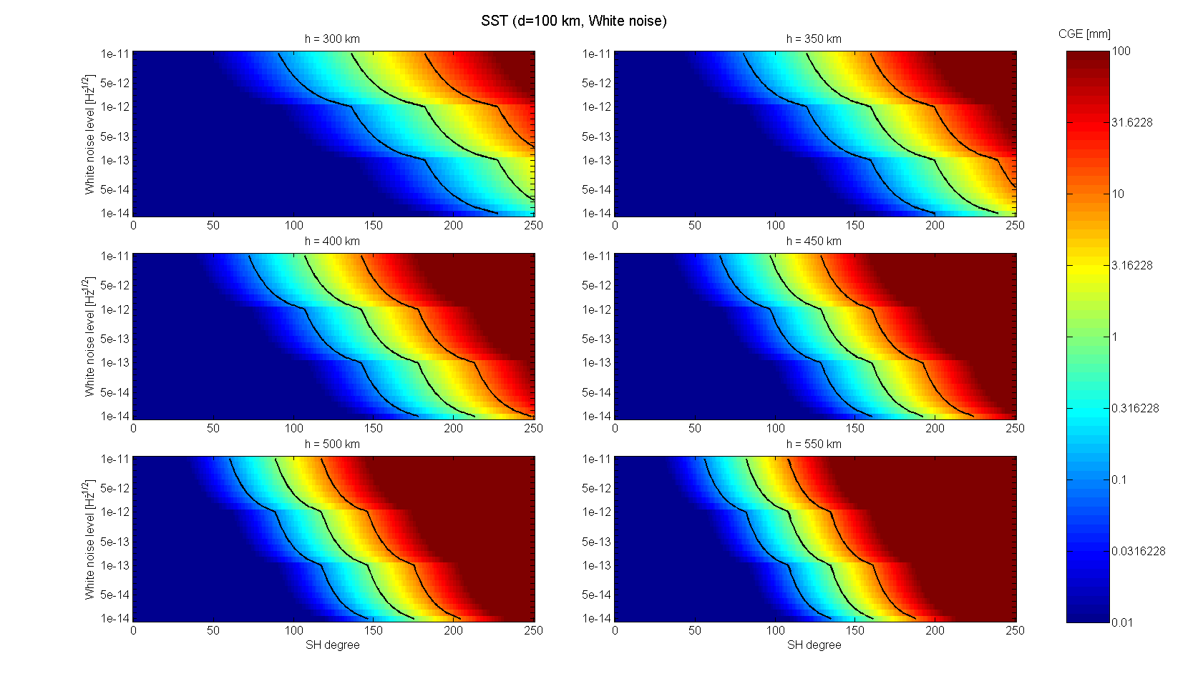
Figure 3: Cumulative Geoid Error for the SST sensor system for d=100 km, white noise case (the three black lines in each plot represent the CGE levels 0.1, 1 and 10 mm)

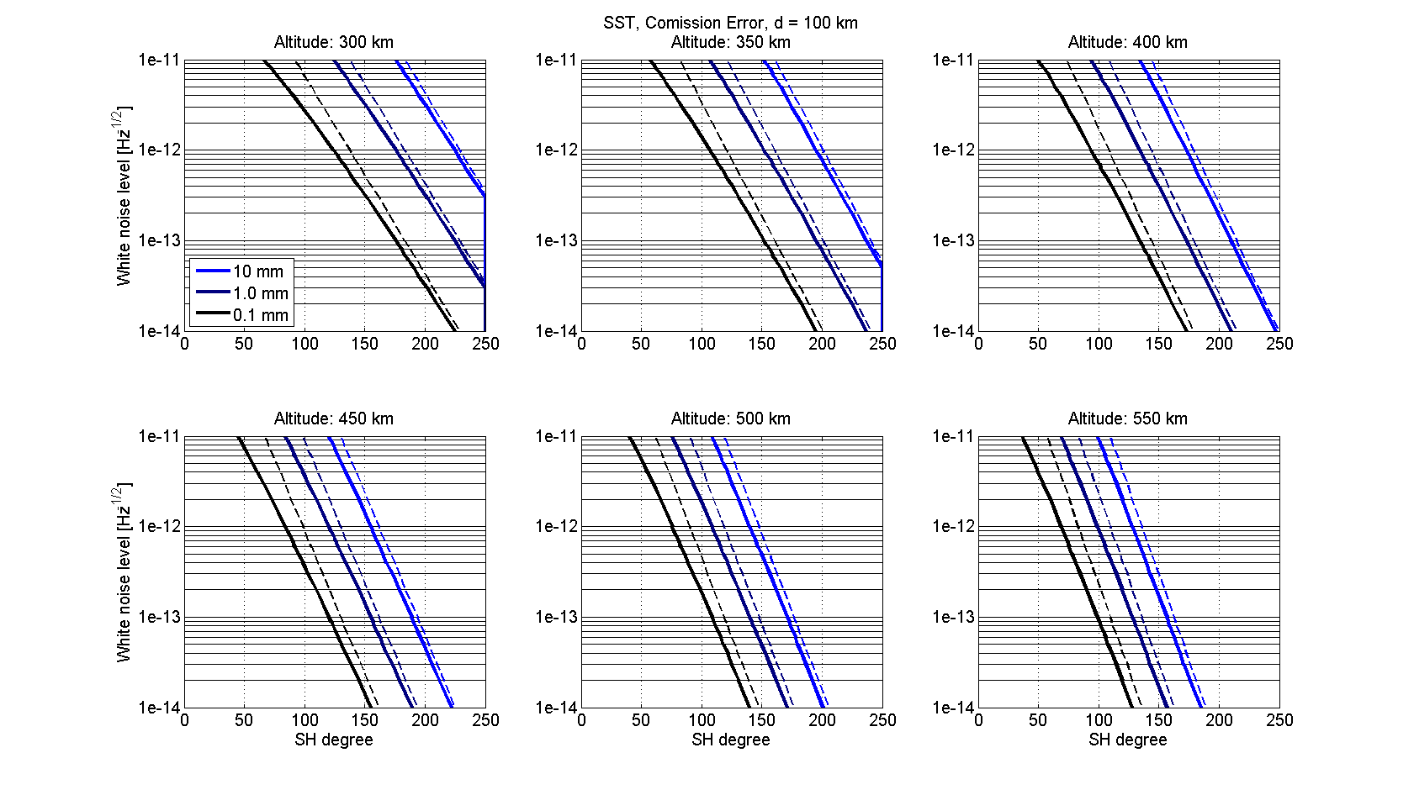
Figure 4: Requirement lines for the SST sensor for d=100 km (solid lines: coloured noise, dashed lines: white noise)

The results of the simulations for d=100 km can be seen in the Figures 2, 3 and 4. The results for the other distances are in Appendix B. In Figure 2 (coloured noise case) and 3 (white noise case), CGEs for the six different altitudes and the 28 different white noise levels can be observed. Figure 4 shows the SH degrees, up to which a simulation stays under each of the three error levels. For example, let’s investigate more closely the coloured noise case for an altitude 300 km. If the given PSD has a noise level for higher frequencies of , a 0.1 mm geoid (black solid line) can be computed up to SH degree 124. Alternatively 1 mm, is reached at SH degree 176. It can be observed, that the different noise assumptions – white or coloured – primarily affect the lower degrees. This is clear, if one again refers to the image on the right side of Figure 1.

With these values one can derive requirements for the ranging sensor system (coloured noise case) for different altitudes. For altitudes higher than 400 km, the CGE for SH degrees 150, 200 and 250 will be higher than the required values. This means, that is not sufficient for these altitudes. For lower altitudes, the following noise levels would arise from the requirements in Table 5.

 |  |  | resulting CGE [mm] for SH degrees
 |  | required noise level | 150 | 200 | 250
Altitude [km] | 300 | 3,E-13 | 0.10 | 0.95 | 10.3
Altitude [km] | 350 | 5,E-14 | 0.04 | 0.66 | 10.3
Altitude [km] | 400 | 1,E-14 | 0.02 | 0.55 | 12.3
Table 5: SST sensor requirements for three altitudes for a distance of 100 km (coloured noise case)

A summary of all requirements for different sensors, altitudes and distances is presented in Chapter 5.

4.1.2 Acceleration measurements (ACC)

Here the influence of the accelerometer sensor system shall be analyzed. We used the same simulation approach as for the SST case. Different error levels are introduced as noise level for a white and a coloured noise case (see Figure 5). The model for the coloured noise case is

The value a represents again the white noise level between 1 and 100 mHz. The simulation results for d=100 km can be seen in the Figures 6, 7 and 8 (Appendix B contain the other distances and altitudes).

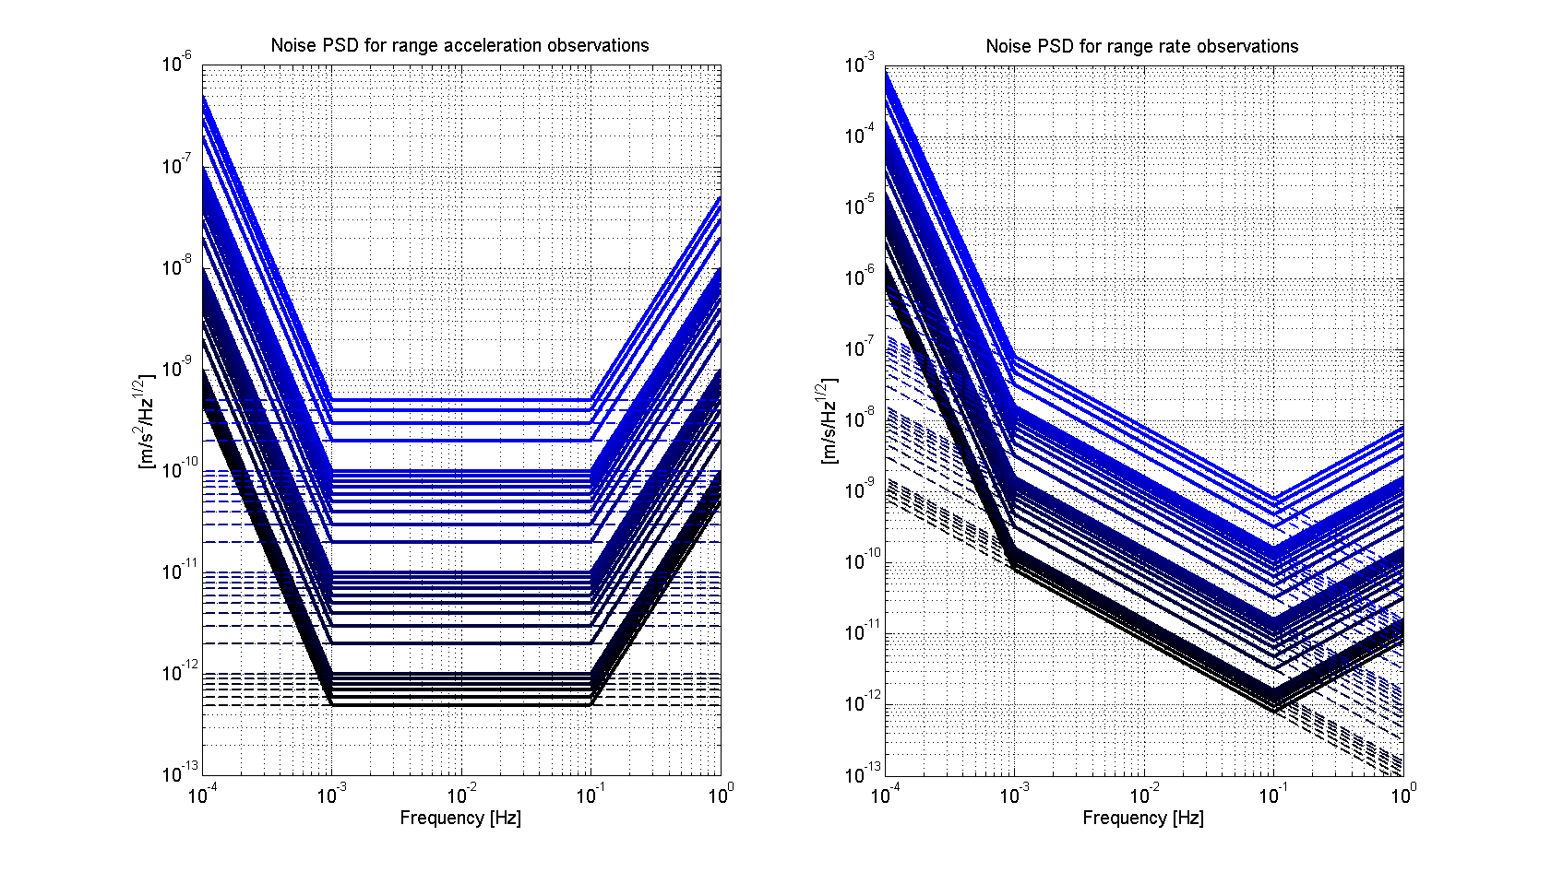
Figure 5: Noise PSDs in terms of range acceleration and range rate observations for the accelerometer sensor system (solid lines: coloured noise, dashed lines: white noise, red lines: Previous NGGM study limit, see references 5.)

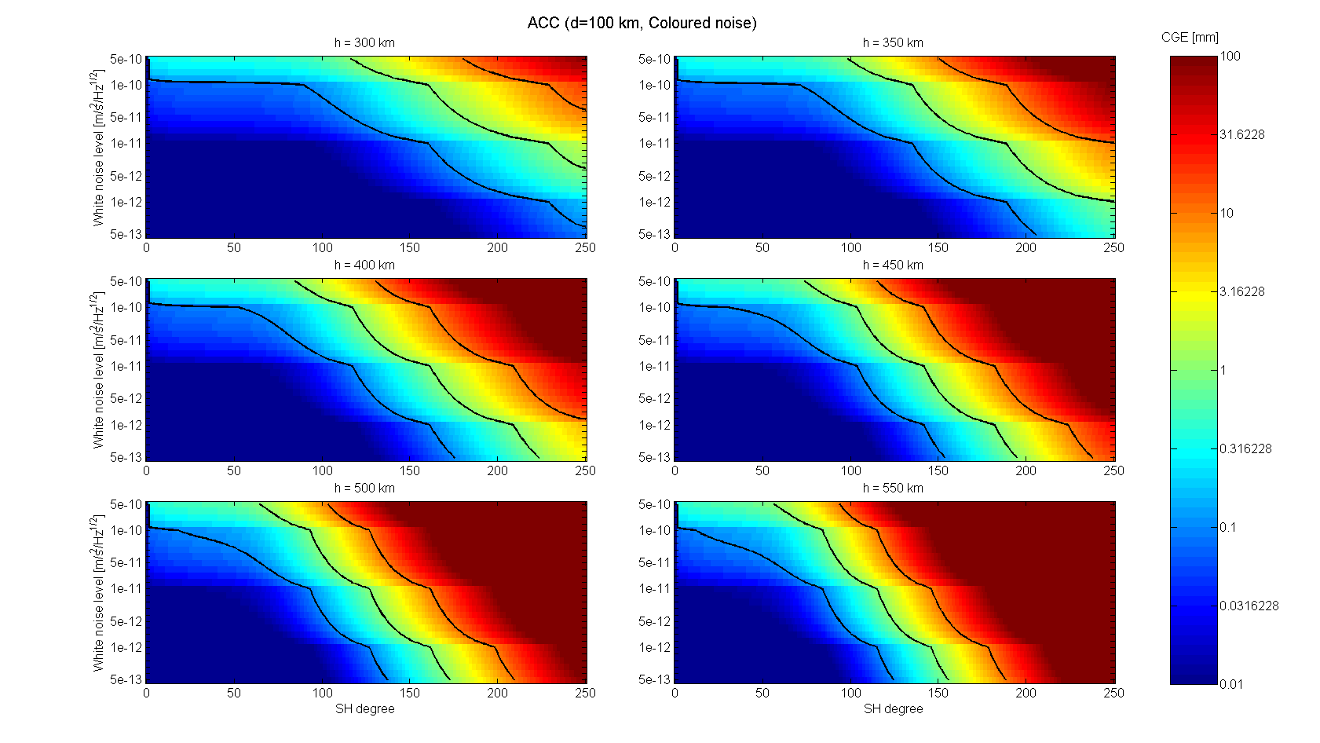
Figure 6: Cumulative Geoid Error for the accelerometer system for d=100 km, coloured noise case (the three black lines in each plot represent the CGE levels 0.1, 1 and 10 mm), the x axis represents the white noise level of the error PSD

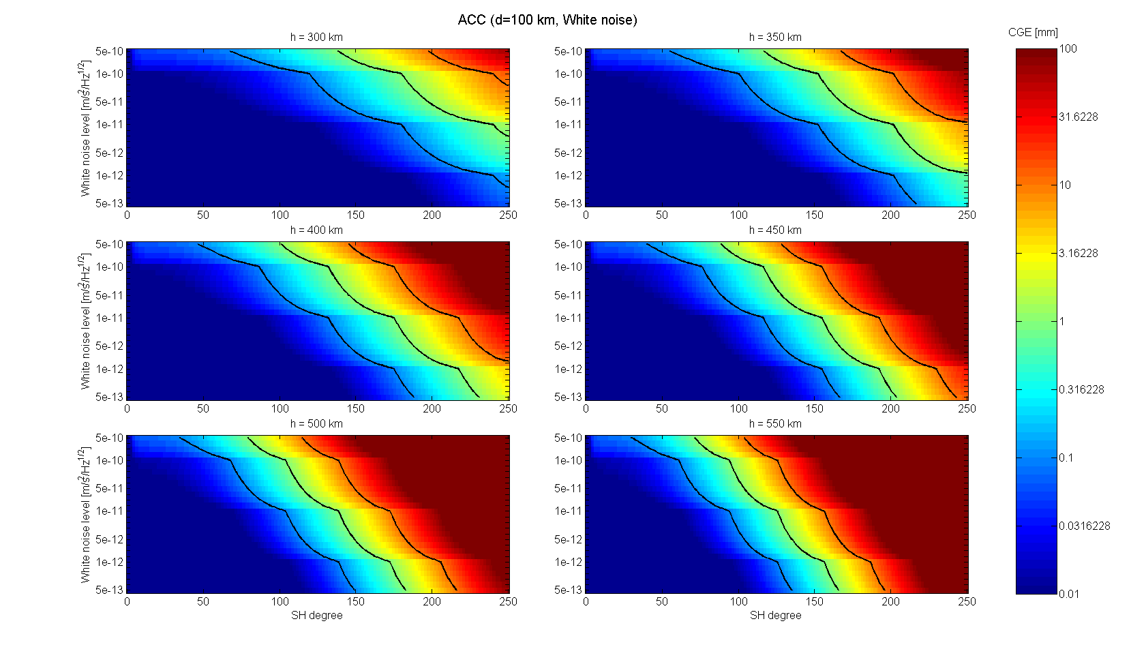
Figure 7: Cumulative Geoid Error for the accelerometer system for d=100 km, white noise case (the three black lines in each plot represent the CGE levels 0.1, 1 and 10 mm)

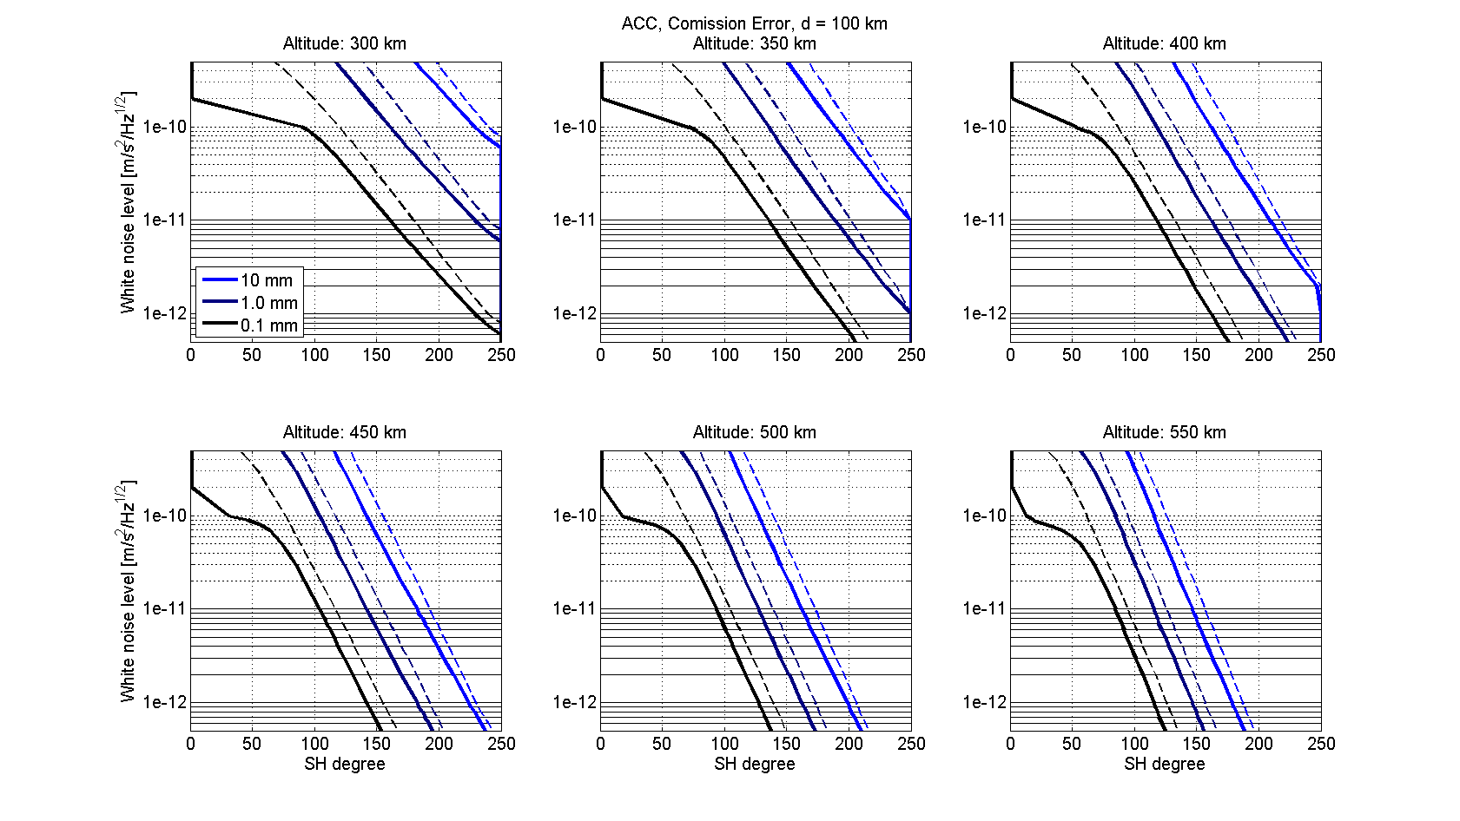
Figure 8: Requirement lines for the accelerometer for d=100 km (solid lines: coloured noise, dashed lines: white noise)

required noise level
[m/s²/Hz^{1/2}]
Altitude [km] | 300 | 2,E-11
Altitude [km] | 350 | 6,E-12
Altitude [km] | 400 | 2,E-12
Table 6: ACC sensor requirements for three altitudes for
a distance of 100 km (coloured noise case)

Table 6 shows the required noise levels for the distance of 100 km and the coloured noise case as an example. All other cases are summarized in chapter 5.

4.1.3 GNSS

Observations of orbit perturbations are not as important as range or accelerometer observations. In general their information is needed to locate the range observations. In a combined gravity field solution this affects only the very low SH degrees. Nevertheless it is important to define sufficient requirements for this observation type as well. In general it can be said that the noise of GNSS observations, i.e. the derived satellite positions should be on a centimetre level. In terms of noise PSDs a figure like the left image of Figure 9 can be expected. Typical noise PSDs for GNSS observations have a white noise behaviour with a maximum around the orbit frequency.
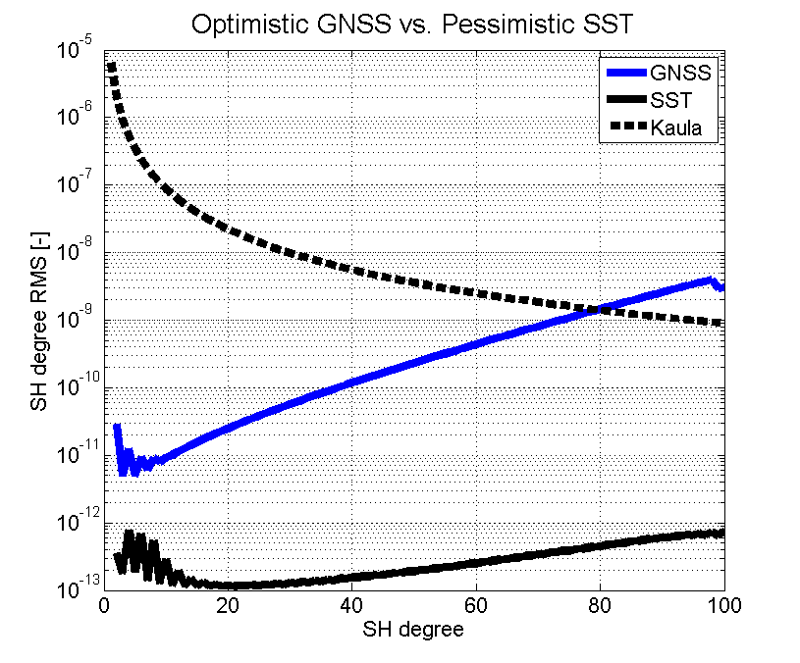
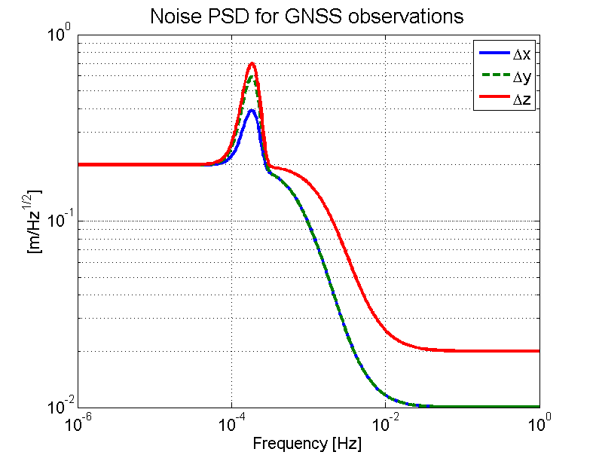
Figure 9, left: Typical noise PSD for LEO positions derived by GNSS
(x: along-track, y: cross-track, z: radial)
right: SH degree RMS comparison of an optimistic GNSS simulation
and a pessimistic SST simulation (d=100 km, h=300 km)

A sensitivity analysis shows that SST gravity field analysis don’t get much profit from GNSS observations. As mentioned before they are mainly used for locating the SST observations in space. The right image of Figure 9 shows SH degree RMS values for the most pessimistic SST performance of Figure 1 compared with an optimistic GNSS performance. This is a white noise behaviour on a level of . It can be observed that the SH degree RMS of the SST simulation stays at least one order of magnitude below the GNSS simulation.

4.1.4 Gradiometry
Sensitivity
The sensitivity of satellite gravity gradiometry (SGG) for the lower SH degrees is very low. Therefore GNSS or SST observations are needed in addition. Without this combination the cumulative errors would be dominated by very large errors in the lower SH degrees. For that purpose again a sensitivity analysis can be seen in the right image of Figure 10. It shows four pessimistic SST simulations compared with SGG simulations in terms of SH degree RMS (only zz-component of the gradient tensor is applied as observation). A full gradiometer could improve the zz-only solution by a factor of 1.5 in terms of SH degree RMS. For gradiometry, noise PSDs of different quality levels are assumed, which can be seen in the left image of Figure 10. These models are adopted from the initial error model for ACC.

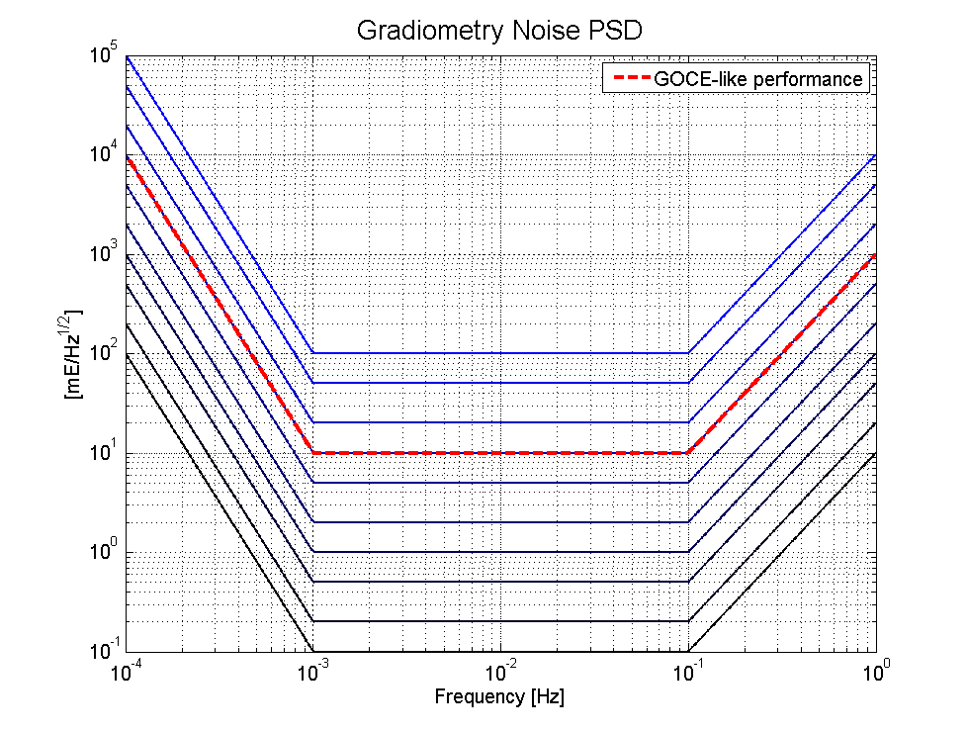
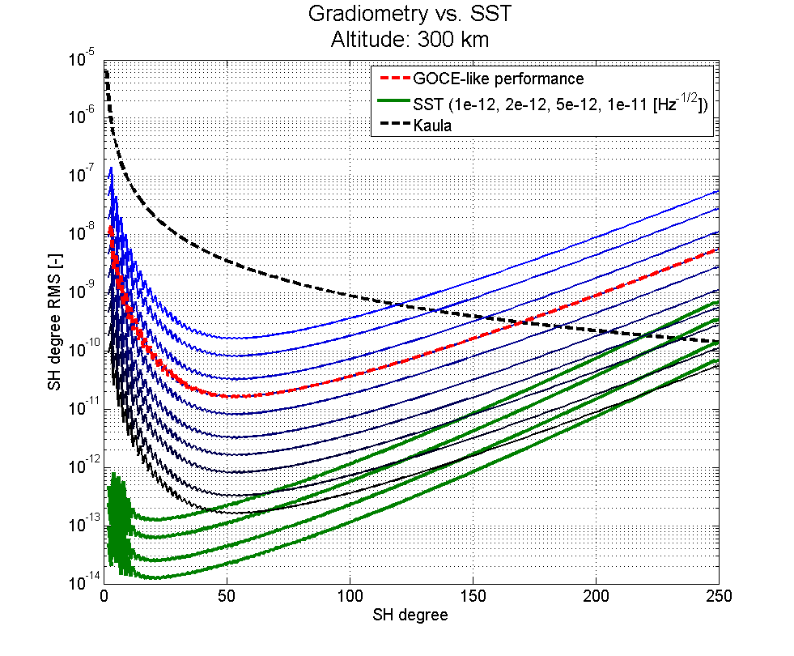

Figure 10, left: Typical noise PSDs for Gradiometry observations
right: SH degree RMS comparison of Gradiometry simulations (blue and black curves) and SST simulations (d=100 km, h=300 km), the SST performances shown here have white noise levels of with

Let’s investigate more closely the right image of Figure 10. There the SH degrees can be detected, where gradiometry observations could improve a SST gravity field (at least in that example for an altitude of 300 km and a satellite separation of 100 km). The best gradiometry performance in Figure 10 represents approximately a 100 times better GOCE performance. The best SST performance in that plot has a white noise level of , which is two times worse than the previous NGGM study limit. If one compares these two SH degree RMS curves, it can be observed, that only for the highest SH degrees above approx. 220 an improvement from gradiometry can be expected.

4.2 NGGM reference error scenario

4.2.1 Combination of SST and ACC

One further error scenario is analyzed in this chapter. It contains noise PSDs for the satellite-to-satellite distance measurement and for the non-gravitational relative acceleration measurement. It holds for the mean distance between the satellites of 75 km (See reference 4).

The model of the satellite-to-satellite distance measurement error spectral density is
.
It is the same as the initial one for SST if you set and . The model of the non-gravitational relative acceleration measurement error spectral density is
.

A graphical representation of this error scenario can be seen in Figure 11 in terms of range rate observations.

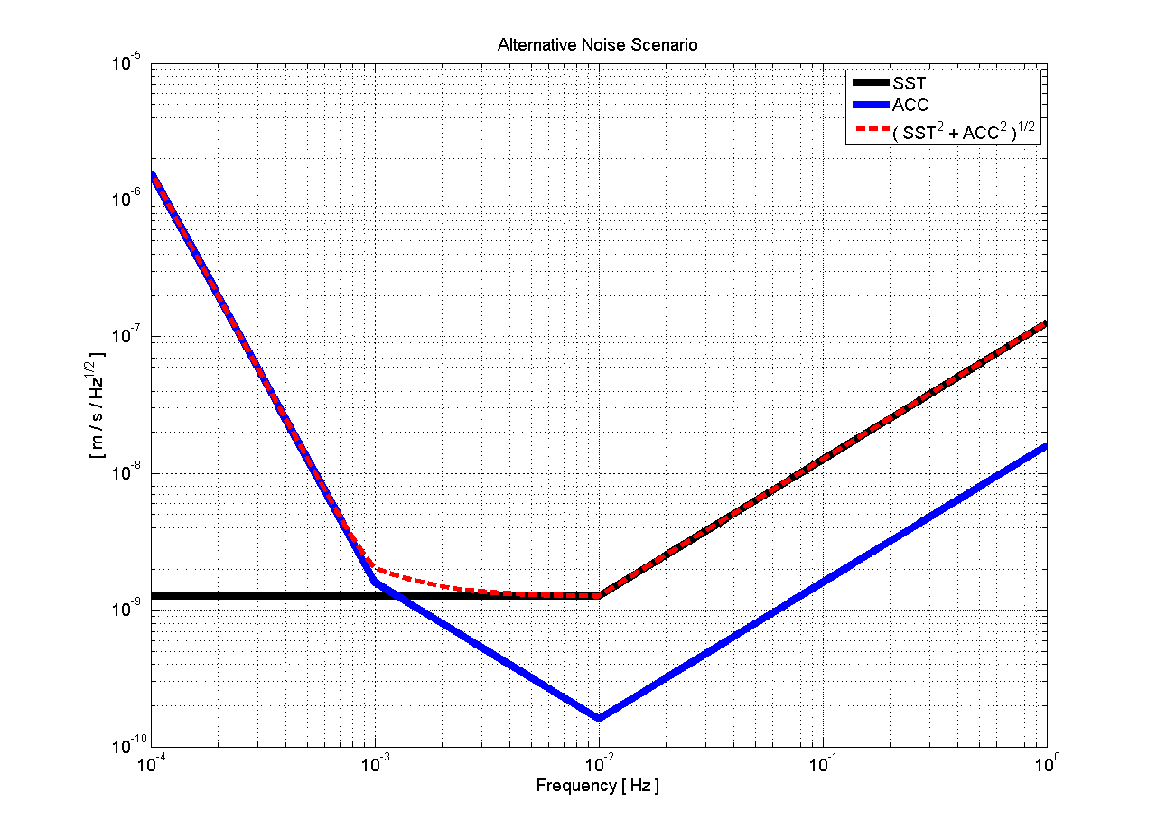
Figure 11: NGGM reference noise scenario for a mean distance of 75 km

The differences to the non-gravitational relative acceleration measurement error scenarios in 4.1.2 are the behaviour (instead of ) for the lower frequencies and the behaviour for frequencies above 10 mHz (instead of 100 mHz). The second difference will not lead to very different CGEs for the combined case (SST and ACC) because the high frequencies are dominated by the SST noise (See also Figure 11). The simulation results in terms of CGEs are presented in Figure 12 in the same way as Figure 2 and 6 for six different mission altitudes.
Several noise levels are analyzed. Different levels are computed by taking the reference noise models from above and decrease step by step the first factor. This is represented by the number k (k=0 stands for the two numbers from above: for the SST and for the ACC sensor). All chosen levels are listed in Table 7.

K | SST | ACC |  | k | SST | ACC
0 | 2,E-08 | 1,E-11 |  | k | SST | ACC
1 | 1,E-08 | 9,E-12 |  | 11 | 9,E-10 | 8,E-13
2 | 9,E-09 | 8,E-12 |  | 12 | 8,E-10 | 7,E-13
3 | 8,E-09 | 7,E-12 |  | 13 | 7,E-10 | 6,E-13
4 | 7,E-09 | 6,E-12 |  | 14 | 6,E-10 | 5,E-13
5 | 6,E-09 | 5,E-12 |  | 15 | 5,E-10 | 4,E-13
6 | 5,E-09 | 4,E-12 |  | 16 | 4,E-10 | 3,E-13
7 | 4,E-09 | 3,E-12 |  | 17 | 3,E-10 | 2,E-13
8 | 3,E-09 | 2,E-12 |  | 18 | 2,E-10 | 1,E-13
9 | 2,E-09 | 1,E-12 |  | 19 | 1,E-10 | 9,E-14
10 | 1,E-09 | 9,E-13 |  | 20 | 9,E-11 | 8,E-14
Table 7: Different error levels for the NGGM reference noise scenario

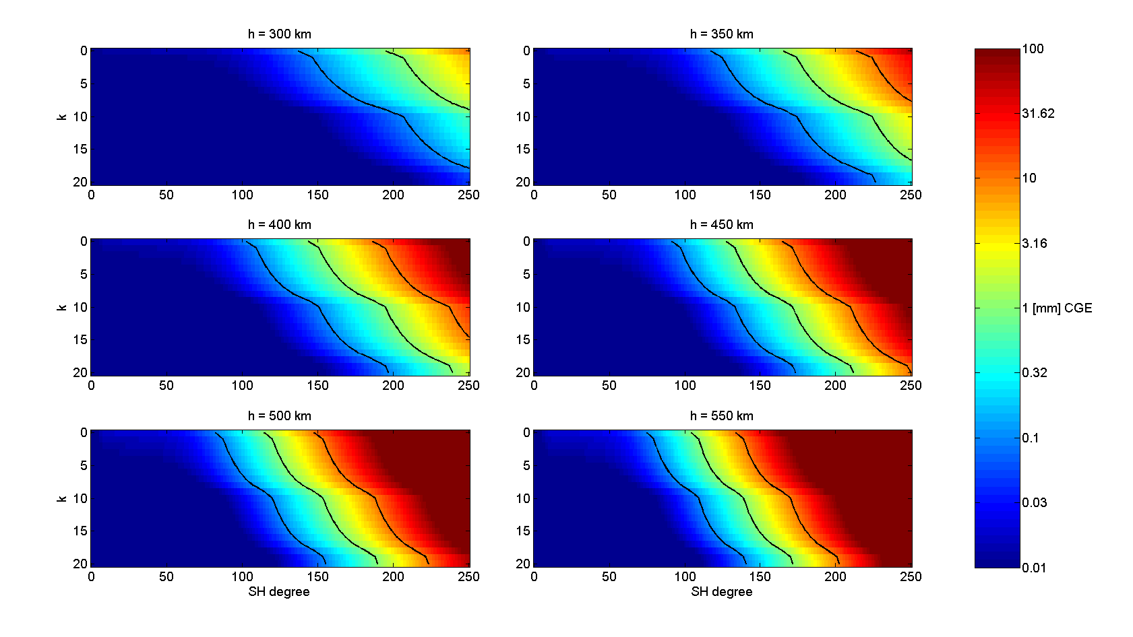
Figure 12: Cumulative Geoid Error for
for d=75 km, reference error scenario.
The three black lines in each plot represent the CGE levels 0.1, 1 and 10 mm.
The y-axis k stands for different error levels (See Table 6)

These results then lead to requirements for k to reach the science requirements of Table 4. The required numbers k can be seen in Table 8 with their noise levels for the two types of sensors and the resulting CGEs.

Altitude | k | SST | ACC | CGE [mm]
[km] | k | SST | ACC | 150 | 200 | 250
300 | 3 | 8,E-09 | 7,E-12 | 0.09 | 0.62 | 4.31
350 | 8 | 3,E-09 | 2,E-12 | 0.09 | 0.86 | 9.09
400 | 15 | 5,E-10 | 4,E-13 | 0.05 | 0.64 | 9.32
450 | 20 | 9,E-11 | 8,E-14 | 0.02 | 0.49 | 10.15
Table 8: required noise levels for the reference error scenario

Gradiometry
Redundancy and CGE
Chapter 4.1.4 shows comparisons in terms of SH degree RMS of separate simulations for SST or SGG. Now a combination of both sensors on one satellite shall be compared with a SST only simulation.
The SGG noise scenario shown in Figure 10 left has the same characteristics as the initial accelerometer error scenarios (see Figure 5). For the following analyses an error scenario is chosen, which is adopted from the reference scenario for the non-gravitational relative acceleration measurements (see chapter 4.2.1). The other simulation parameters holding for that example are an altitude of 300 km and a mean distance between the satellites of 75 km. We know from 4.1.4, that we have to go down with the white noise level to 0.1 mE to get a better sensitivity for the very high degrees in terms of RMS per degree. This noise level is chosen for the following simulations. Therefore the model for the SGG observations can be described as
.
For the range rate observations the reference error scenario described in 4.2.1 is used (Figure 11, red dashed line). This range rate observations lead to a SH error characteristic as in the upper image of Figure 13. It shows the typical error behaviour for that type of observations: very high sensitivity for the low degrees and low orders, worse sensitivity for high orders (sectorial coefficients).
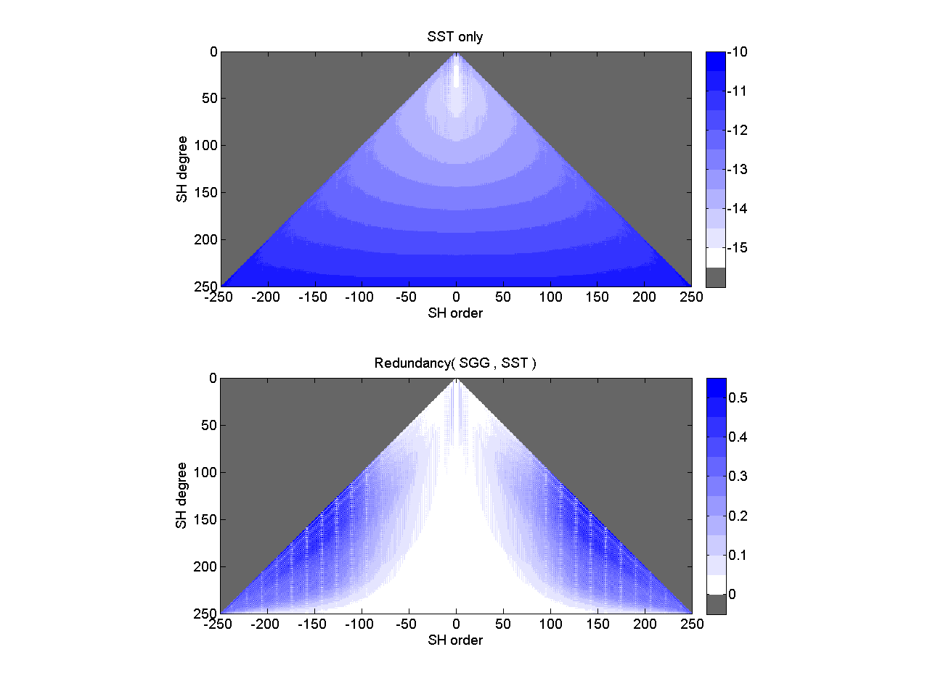
Figure 13, top: SH error spectrum of an SST only solution (reference error scenario, altitude 300 km, distance 75 km, log₁₀ scaling)
bottom: Redundancy of SST-SGG combination compared to SST-only

The lower image of Figure 13 shows the redundancy of the combination of SST and SGG compared to SST only in terms of variances. For every SH order and degree the redundancy is . So a redundancy of 0.1 means a ten percentage reduction of the SST only variance by combining it with SGG.
What this means in terms of CGE can be seen in Figure 14. On the left side the cumulative errors are slightly above the requirements (0.1 mm for SH degree L=150, 1 mm for L=200 and 10 mm for L=250) for the combination and SST only. The difference is in the order of one magnitude less. On the right side the improvements are plotted, which have their maximum around L=150 at about 22 %.

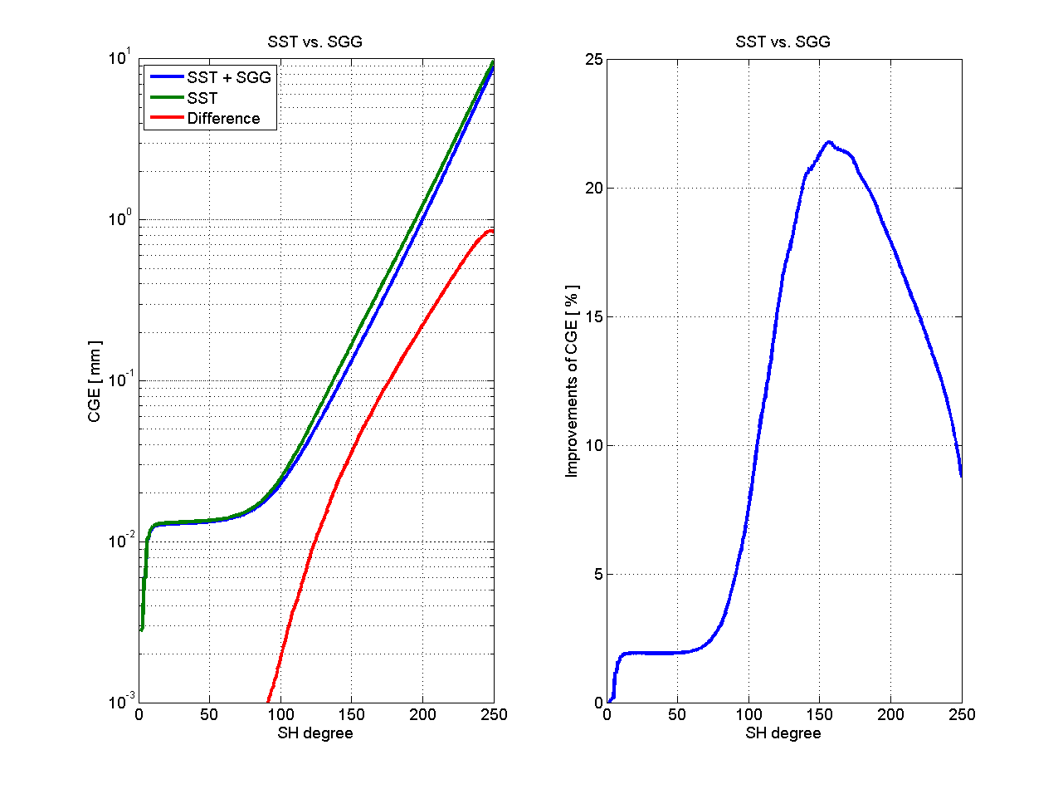
Figure 14, left: CGEs of SST-SGG combination compared to SST only
right: improvements of SST only CGEs by combination with SGG

So to sum up the gradiometry part, it can be said, that a low-low SST mission won’t get much benefit from additional SGG observations in terms of geoid errors. What can be expected is nevertheless a more isotrope error structure of the combined solution. This is because of the higher sensitivity in the combined case for the sectorials (see Figure 13).

Extended white noise part
The next simulations shall analyze what accelerometers can contribute with an extended white noise part. The white noise part of the reference model of the non-gravitational relative acceleration measurement in chapter 4.2.1 lasts from 1 mHz to 10 mHz. Lets assume an extended white noise part from 1 mHz to 100 mHz. The white noise level is chosen to be very low to get sensitive gradiometry observations. Analytical, the error spectral density of the acceleration measurement can be written as
.
For the distance measurement the same model holds as in 4.2.1. As before two NGGM scenarios are compared. One with range rate observations only, taking into account the error spectra of the SST and the ACC part. The second mission provides additional gradiometry observations, in this case all three diagonal components (V_{xx}, V_{yy}, V_{zz}). As the noise characteristic of the gradiometry observations depends on the accelerometer characteristic for both sensors there is chosen a very low level to get significant redundancies of the gradiometry combination. This white noise level is for ACC and for SGG. Three different nominal distances are analyzed (75 km, 100 km, 125 km), which lead to different SST noise levels as this is assumed to be distance dependent. In Figure 15 the noise spectral densities for these comparisons are shown.

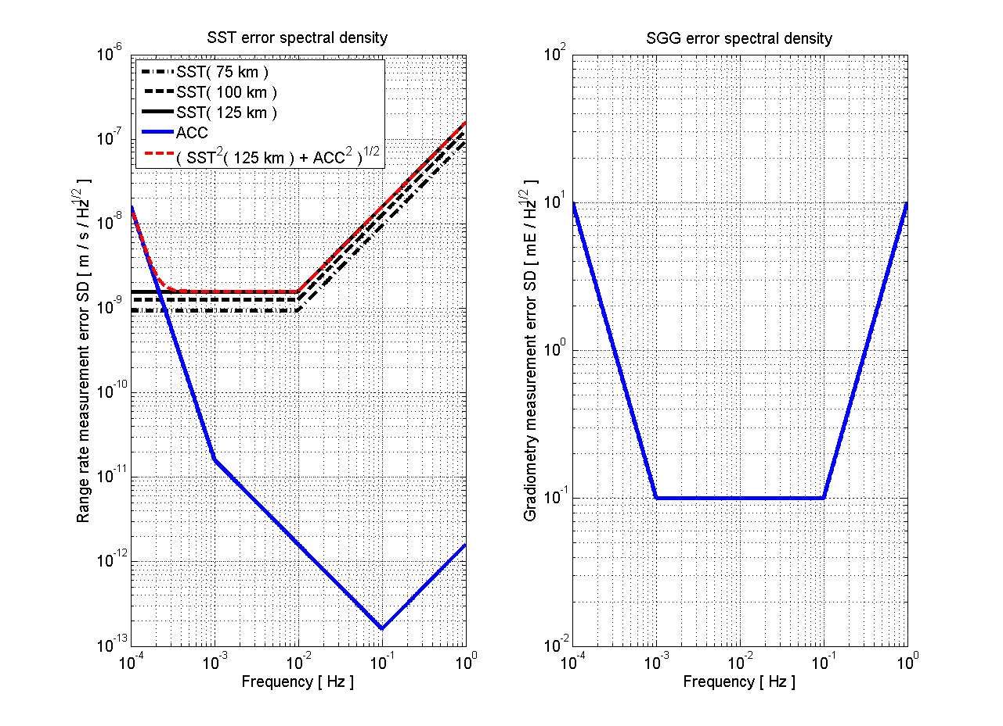
Figure 15, left: Error spectral densities of range rate observations for three different distances (black), error spectral density of an accelerometer with white noise level of (blue) and the resulting total noise spectral density for 125 km distance (red)
Right: Error spectral density of gravity gradiometry observations with white noise level

For the altitude a reference value of 300 km is chosen. The altitude has the same impact on the gravity sensitivity of both sensors. Therefore different altitudes would lead to the same results which are given in percentage of error reduction. Figure 16 shows the redundancies for the whole SH spectrum in three triangular plots on the right and the redundancy per SH degree derived from SH degree RMS on the left.

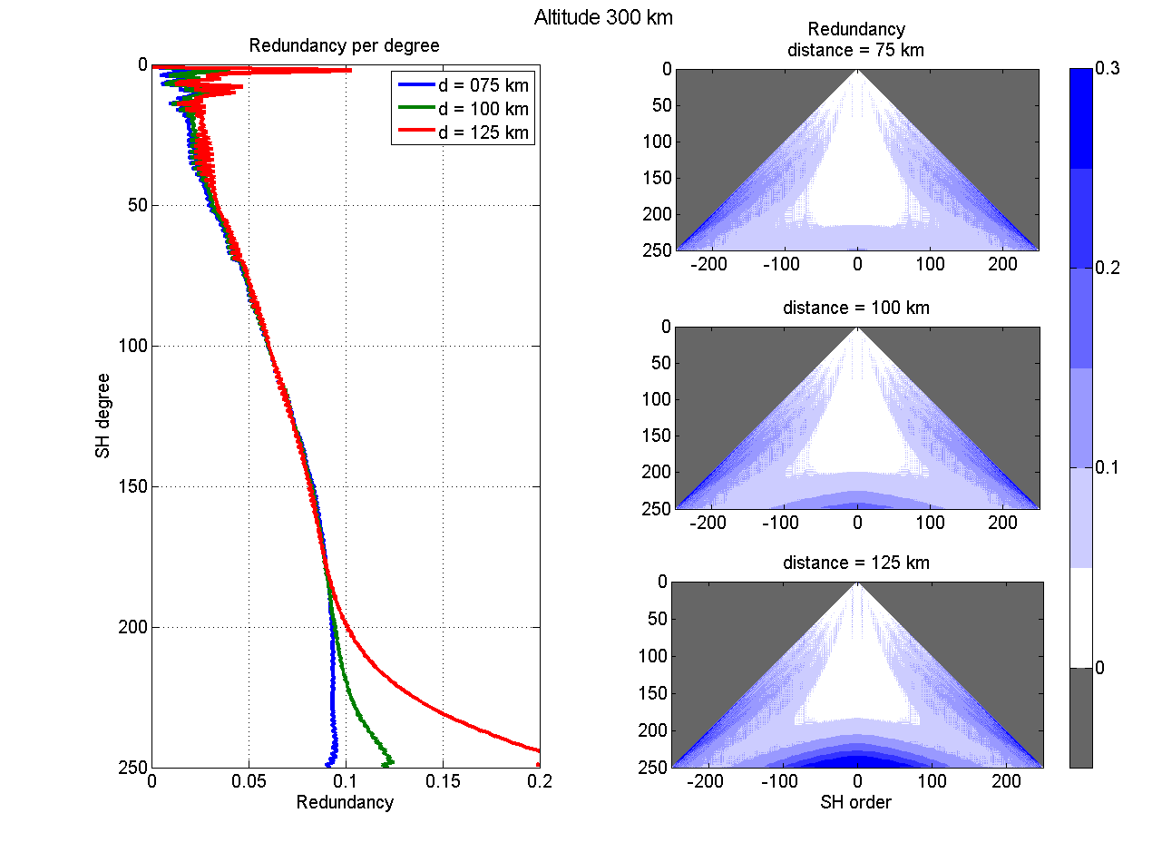
Figure 16: Redundancy of SST-SGG combination compared to SST-only for the SH spectrum for three different distances (right) and per SH degree (left)

Figure 16 shows how the combination with SGG can improve a SST-only the gravity field solution. Compared with Figure 13 bottom similar structures can be seen. The redundancy values for the sectorials are a bit lower. This is because of the two magnitudes lower white noise level of the accelerometer sensor. With the distance the error level of the SST measurements and therefore the redundancy increases for higher SH degrees.
It can be said that such a gradiometer (0.1 mE white noise level) can decrease the SST-only gravity field coefficient errors by up to 30 percent mainly for the sectorials. This brings improvements of CGEs comparable to Figure 14 (max. 20 %) but higher improvements for SH degrees over 200 thanks to the extended white noise frequency interval.
By increasing the sensitivity of the sectorials the error structure becomes more isotropic. As the spatial error structure of an in-line GRACE-like SST-only mission shows high correlation with the satellite orbit and the measurement direction (North-South stripes) this combination could also improve this characteristic. Full-scale simulations can provide a closer look on that combination and on the benefit in temporal gravity signal retrieval.

Summary
In this Chapter a summary of all the simulations done for this study is presented. The main goal is the definition of requirements for each sensor.

Initial error scenario
At first the requirements for the SST and the ACC sensor and the initial error scenario are shown. Table 9 shows for each simulated altitude and satellite distance and for the two sensor types a value of maximum noise level. This noise level represents for the SST sensor the relative noise level for frequencies above in (See Figure 1). For the accelerometer it is the noise level for in (See Figure 5). These requirements directly come from the CGE requirement Table 4. To reach the values of Table 4, the noise level of the sensor mustn’t be larger than the values in Table 9 in each of the different profiles for altitude and distance.

 |  |  | Satellite Separation [km]
 |  |  | 50 |  | 100 |  | 200 |  | 300
 |  |  | wn | cn | wn | cn | wn | cn | wn | cn
SST | Altitude [km] | 300 | 5,E-13 | 4,E-13 | 4,E-13 | 3,E-13 | 4,E-14 | 4,E-14 | 3,E-14 | 3,E-14
SST | Altitude [km] | 350 | 8,E-14 | 7,E-14 | 6,E-14 | 5,E-14 | <1,E-14 | <1,E-14 | <1,E-14 | <1,E-14
SST | Altitude [km] | 400 | 2,E-14 | 2,E-14 | <1,E-14 | <1,E-14 | <1,E-14 | <1,E-14 | <1,E-14 | <1,E-14
SST | Altitude [km] | 450 | <1,E-14 | <1,E-14 | <1,E-14 | <1,E-14 | <1,E-14 | <1,E-14 | <1,E-14 | <1,E-14
SST | Altitude [km] | 500 | <1,E-14 | <1,E-14 | <1,E-14 | <1,E-14 | <1,E-14 | <1,E-14 | <1,E-14 | <1,E-14
SST | Altitude [km] | 550 | <1,E-14 | <1,E-14 | <1,E-14 | <1,E-14 | <1,E-14 | <1,E-14 | <1,E-14 | <1,E-14
SST | Altitude [km] | 600 | <1,E-14 | <1,E-14 | <1,E-14 | <1,E-14 | <1,E-14 | <1,E-14 | <1,E-14 | <1,E-14
ACC | Altitude [km] | 300 | 2,E-11 | 8,E-12 | 4,E-11 | 2,E-11 | 7,E-11 | 3,E-11 | 9,E-11 | 5,E-11
ACC | Altitude [km] | 350 | 6,E-12 | 3,E-12 | 2,E-11 | 6,E-12 | 3,E-11 | 2,E-11 | 3,E-11 | 2,E-11
ACC | Altitude [km] | 400 | 2,E-12 | 8,E-13 | 3,E-12 | 2,E-12 | 5,E-12 | 3,E-12 | 6,E-12 | 5,E-12
ACC | Altitude [km] | 450 | <5,E-13 | <5,E-13 | <5,E-13 | <5,E-13 | 8,E-13 | 6,E-13 | 1,E-12 | 9,E-13
ACC | Altitude [km] | 500 | <5,E-13 | <5,E-13 | <5,E-13 | <5,E-13 | <5,E-13 | <5,E-13 | <5,E-13 | <5,E-13
ACC | Altitude [km] | 550 | <5,E-13 | <5,E-13 | <5,E-13 | <5,E-13 | <5,E-13 | <5,E-13 | <5,E-13 | <5,E-13
ACC | Altitude [km] | 600 | <5,E-13 | <5,E-13 | <5,E-13 | <5,E-13 | <5,E-13 | <5,E-13 | <5,E-13 | <5,E-13
Table 9: Requirements for the SST sensor and the accelerometer to meet the required CGE values of Table 4 (wn: white noise, cn: coloured noise). Every mission profile belonging to a grey box will not meet the requirements with the minimum noise levels. The different colours should mark different levels (e.g. SST green: , yellow: and orange: )

The next question is which errors will arise from a combination of both sensors (SST and ACC). This could be simulated in the same way using the square root of the quadratic sum of both noise PSDs. Figure 17 shows this combined case for the distance of 100 km and an altitude of 300 km.

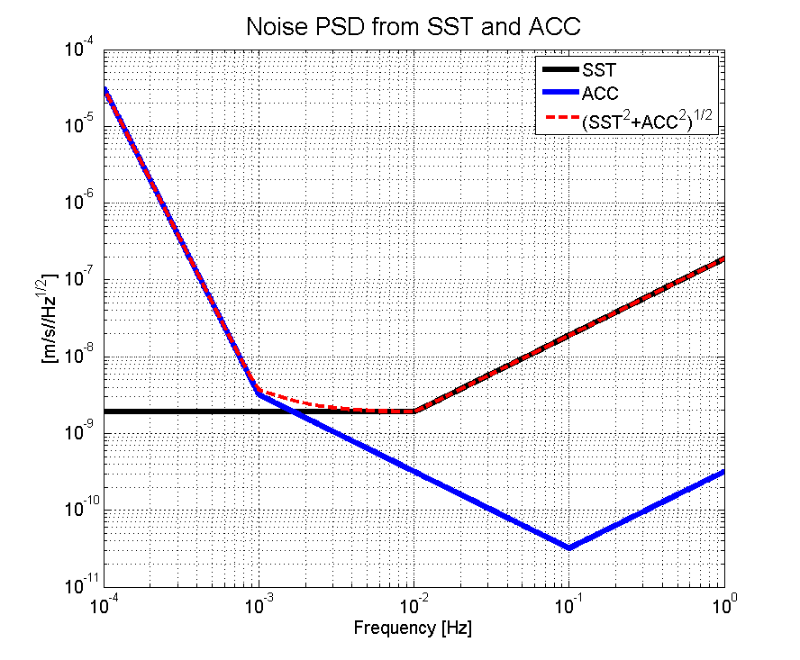
Figure 17: Noise PSD in terms of range rates from SST sensor (d=100 km, white noise level: ) and accelerometer (white noise level: )

Applying the red dashed noise PSD curve to the simulation one gets the following results for CGE (See Figure 18). In addition the results of one and two steps better behaviour are shown. Theses are and for the white noise level of the SST sensor and and for the white noise level of the accelerometer.

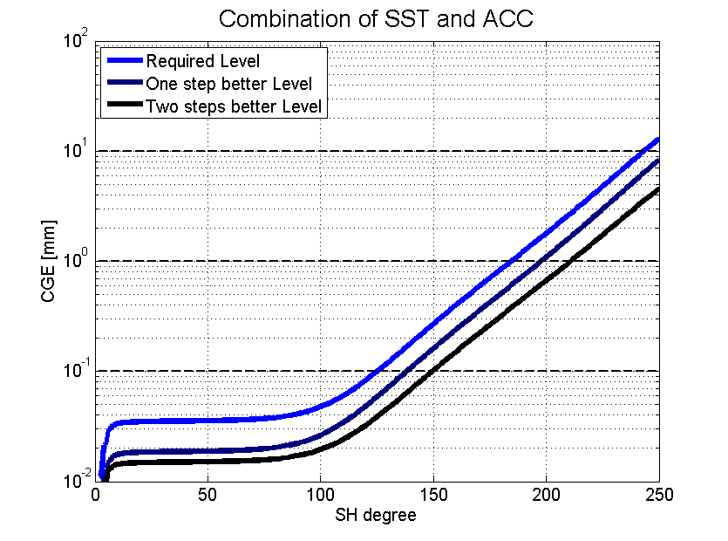
Figure 18: CGE for a combination of SST and ACC noise

From Figure 18 it can be seen, that in a combined case of SST sensor and accelerometer noise the required level of Table 9 for each of the sensors is slightly not sufficient to reach the required CGE values of Table 4. This is clear, if one looks at Figure 17. In that case of an altitude of 300 km and a distance of 100 km it can be observed, that the requirements are met if we apply noise levels of two steps better for each sensor.

5.2 NGGM reference error scenario
In the NGGM reference error scenario (see chapter 4.2.1) the noise levels are slightly different and can be computed with the values in Table 8 and the Formulas in 4.2.1. For one example the model shall be presented here in an analytical and a graphical way. This is again the altitude 300 km and the distance 75 km. From Table 8 it follows, that k must be 3 and therefore the white noise levels of the SST part is and for the ACC part . So the analytical required noise models are
and
.

Figure 19 shows the required noise spectrum in terms of range rates (left) and range accelerations (right).

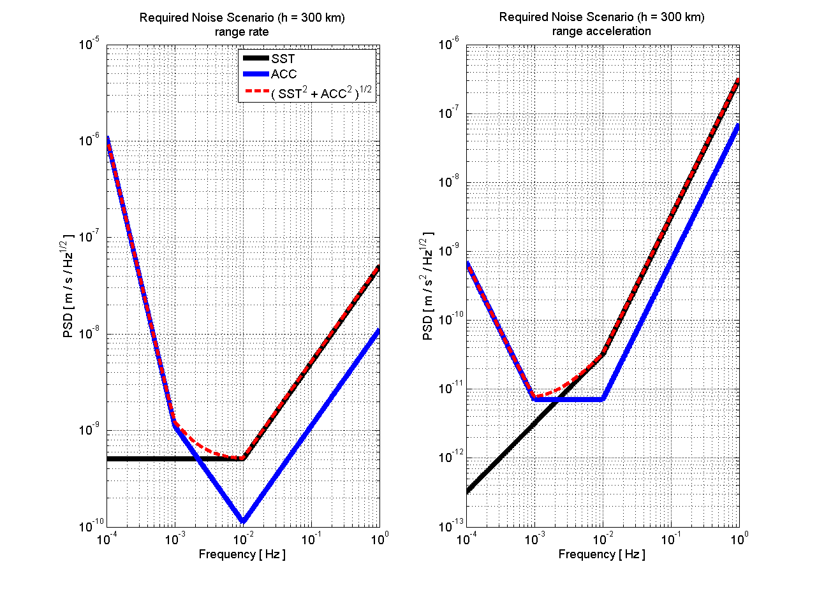
Figure 19: Required error scenario for SST and ACC for an altitude of 300 km (left in terms of range rates, right in terms of range accelerations)
Starting from the reference error models for SST and ACC as described in 4.2.1 all the analyses followed the same strategy. What is the maximum level of all the error levels to reach the science requirements in CGE of Table 4? Here shortly an additional strategy is shown. This strategy does not take only the level into account but also specific characteristics of the model. These characteristics then are changed and the results in CGE are calculated. Again the two main sensors SST and ACC are analyzed. The three specific characteristics of their error spectral densities are:
- the white noise level (SST: for f > 10 mHz, ACC: for 1 mHz < f < 10 mHz)
- the edge frequency to which this white noise level lasts on the left side (SST: 10 mHz, ACC: 1 mHz)
- the rate of the error decreasing for the lower frequencies named with the exponent of the frequency (SST in terms of ranges: -1, ACC in terms of accelerations: -2)

These three characteristics and their values for the reference model are shown in Table 10.

 | SST | ACC
White noise level
Low edge frequency
Low frequency exponent
Table 10: Error spectral density characteristics of the reference model

Applying the reference model as it is with the values in Table 10 it leads to CGEs slightly above the requirements. One can reach the requirements by decreasing each of the six elements in the Table. The maximum values for each of the six fields meeting the requirements are shown in Table 11 together with the percentage of the reference value. This gives information how sensitive the CGE is on which parameter.

 | SST |  | ACC
 | Value | % | Value | %
White noise level |  | 60 |  | 59
Low edge frequency |  | 53 |  | 73
Low frequency exponent |  | 41 |  | 67
Table 11: Sensitivity of CGE on each of the parameters in Table 9

The percentage values in Table 11 show that the low edge frequency of the ACC is the most sensitive parameter. By decreasing the reference value of 1 mHz by 27 % the resulting CGE values meet the requirements. The weakest parameter in that sense is the low frequency exponent of the SST error model. The reference value has to be decreased by 59 % to meet the requirements.

6 Appendix

Appendix A: Error propagation for linear trend estimation

Preliminary Estimation:

There is a regular sampled time series of observations (T=n [years], sampling: Δt [years]). Each observation is independent from the others and equal accurate (standard deviation: σ [mm]). The signal trend should be measured with an accuracy of σ_{t} [mm/year].
Question: Which value is sufficient for σ?

The observation equation is the linear function .The design matrix A and the weight matrix P of the least squares adjustment then are
, .
For the normal equation matrix N it holds
with and .
The accuracy of the trend is the first element of the inverse of N. It is , so for σ it follows:
.

The last approximation holds for monthly measurements. In the case of the nominal mission profile it is an 11 years time series with monthly observations. The secular signal magnitude of signal 1 in Table 2 is 0.01 mm/year. With this approach one get a maximum standard deviation for one single observation of 0.36 mm. Therefore the value in Table 3 of 0.1 mm is obviously sufficient. The same holds for signal 2 in Table 2.

Appendix B: Simulation results

On the following pages simulation results can be seen. The figures are in the same way as the Figures ##, ## and ## and represent the cases with different altitudes and distances.
SST sensor:
Distance: 50 km
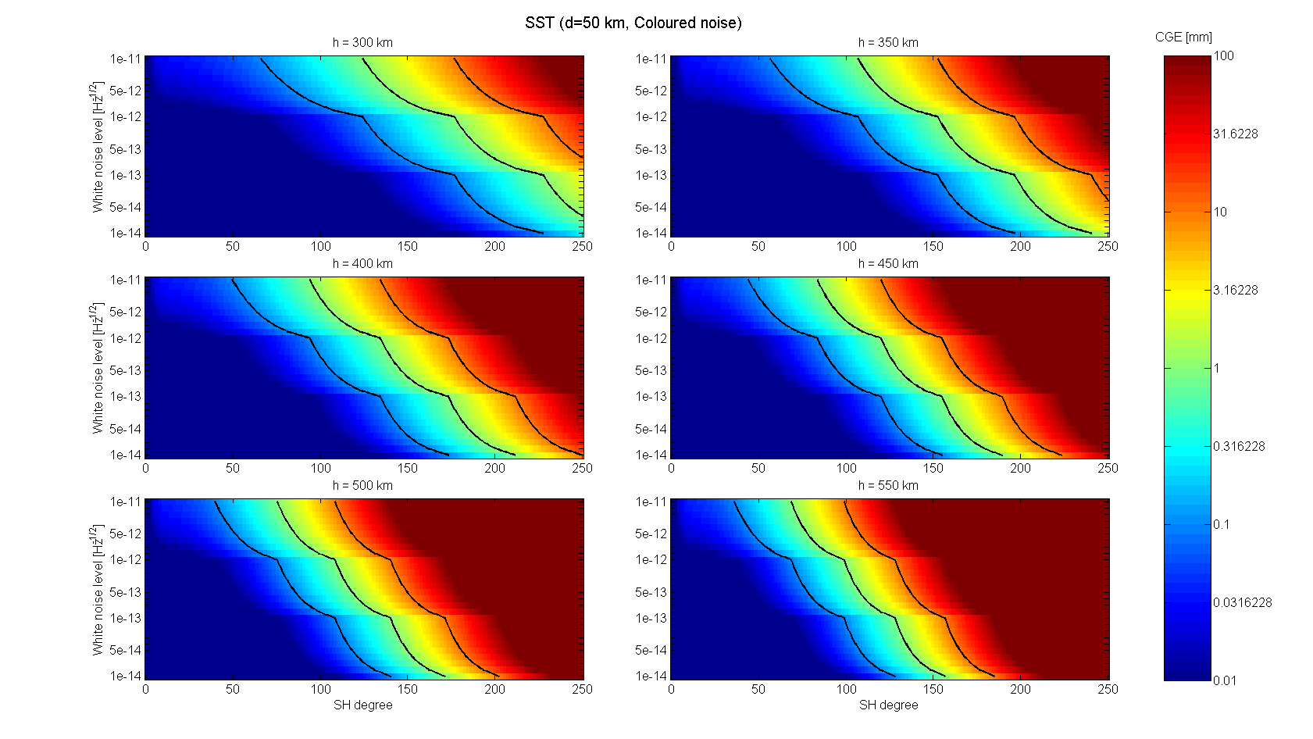
Figure B1: CGE for SST sensor, d=50 km, coloured noise case
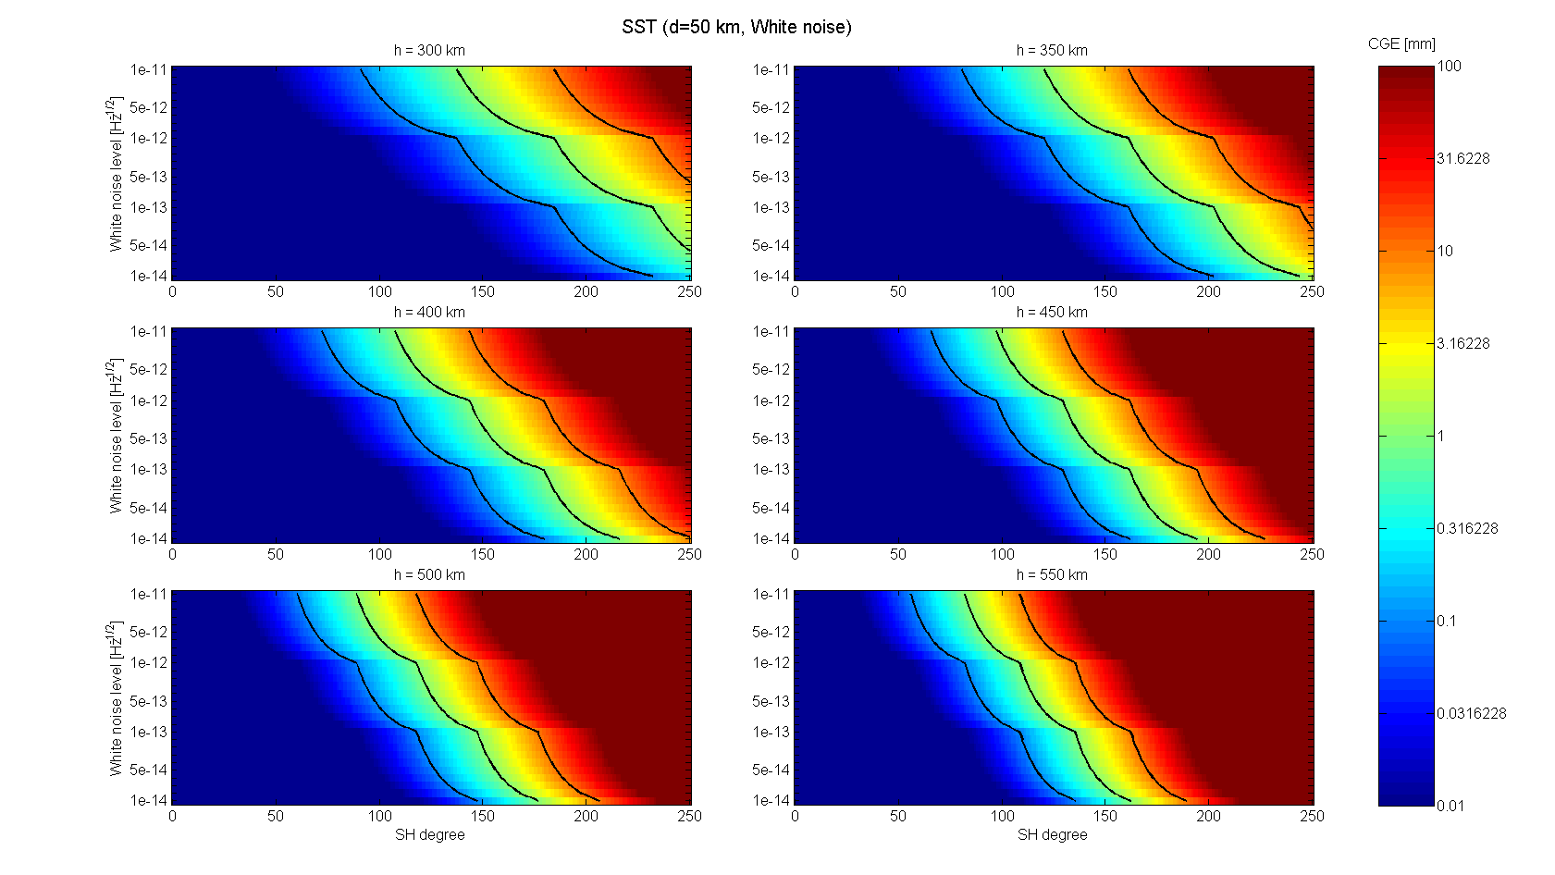
Figure B2: CGE for SST sensor, d=50 km, white noise case
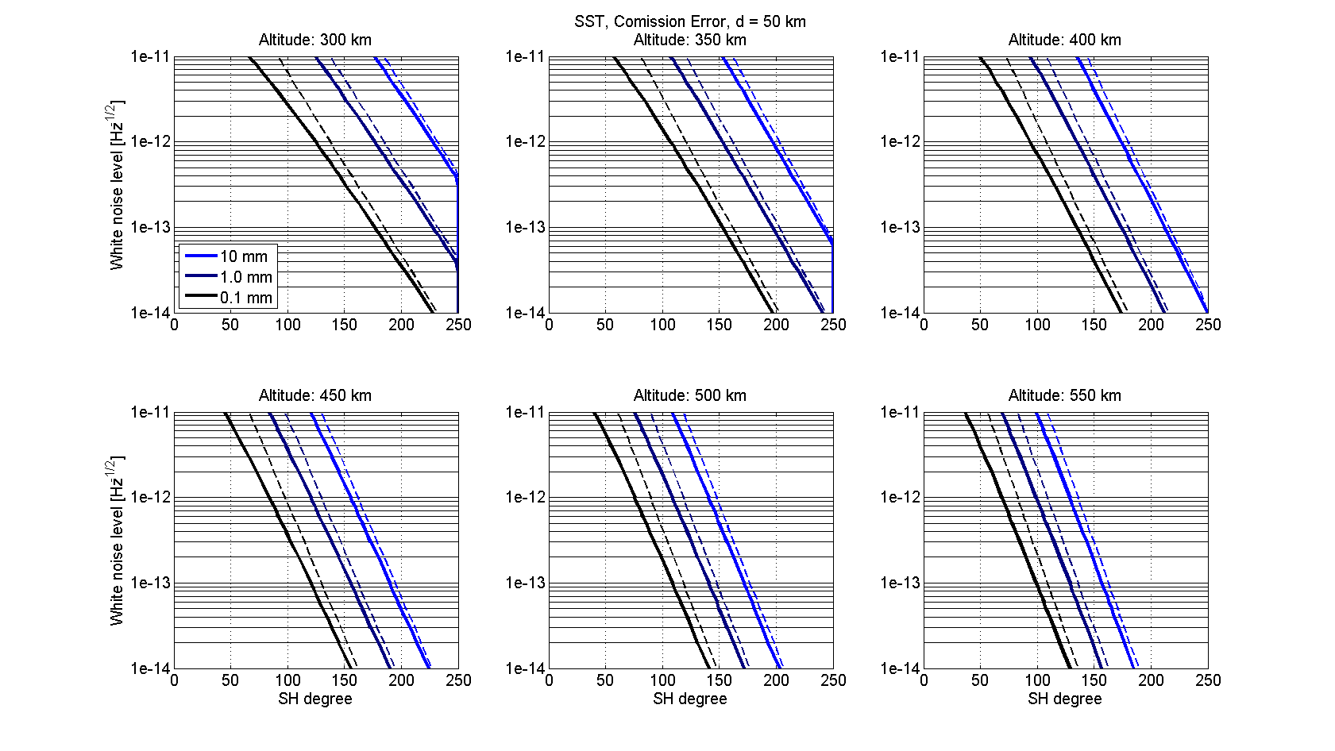
Figure B3: Requirement lines for SST sensor, d=50 km (solid lines: coloured noise, dashed lines: white noise)

SST sensor:
Distance: 200 km
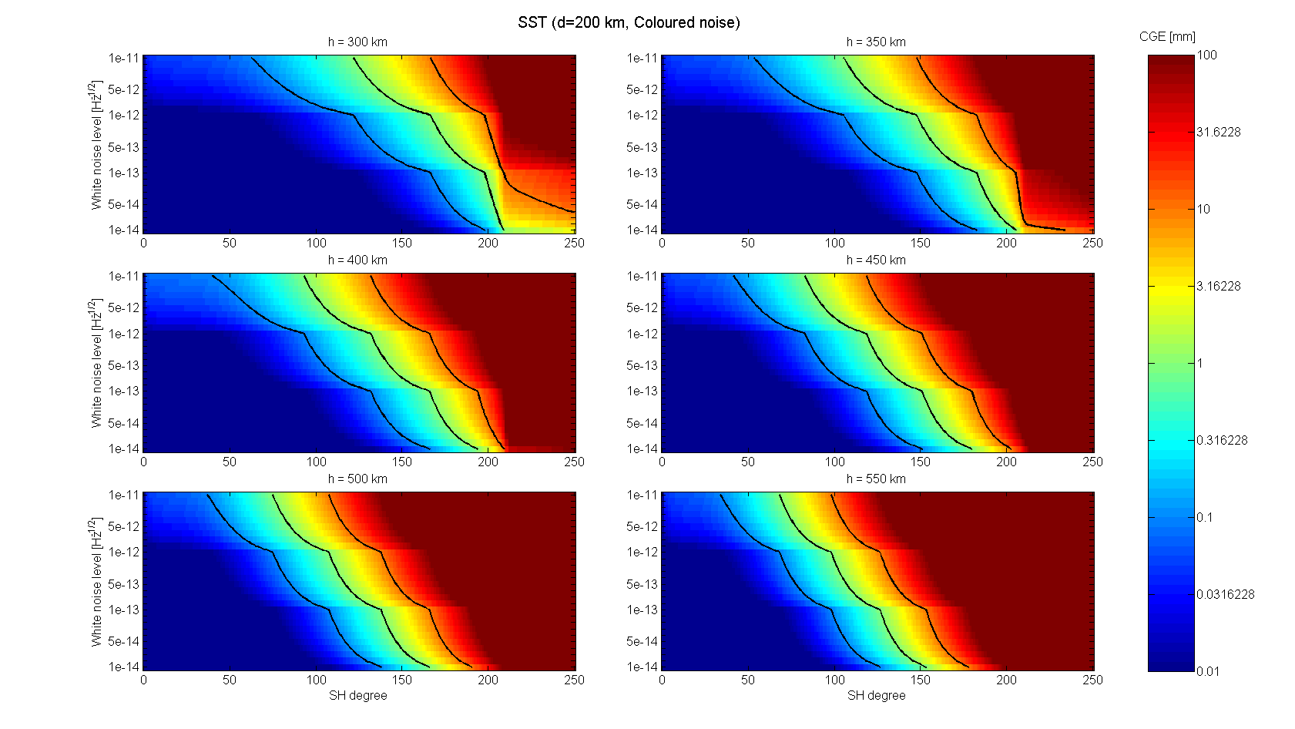
Figure B4: CGE for SST sensor, d=200 km, coloured noise case
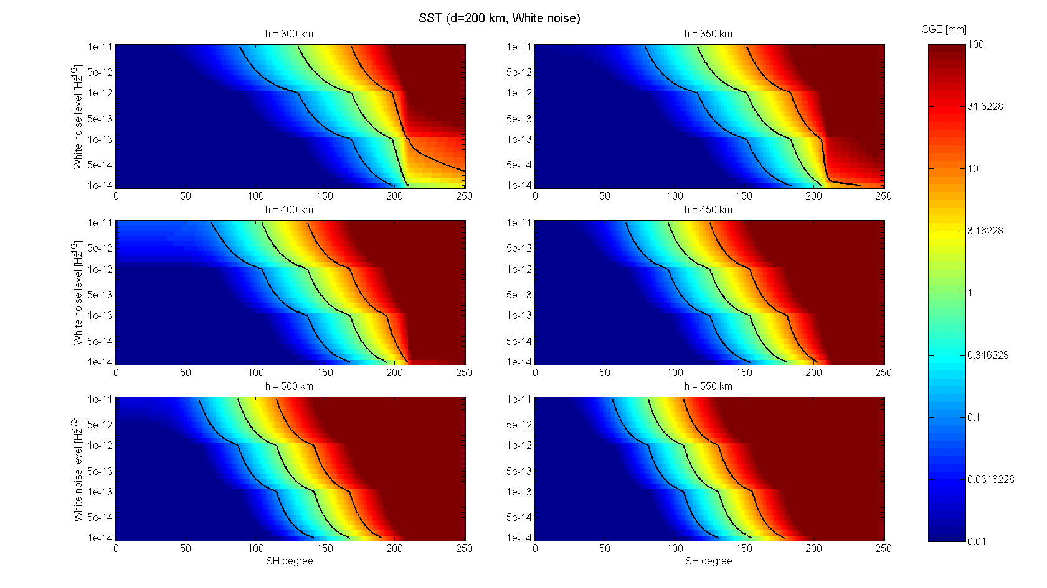
Figure B5: CGE for SST sensor, d=200 km, white noise case
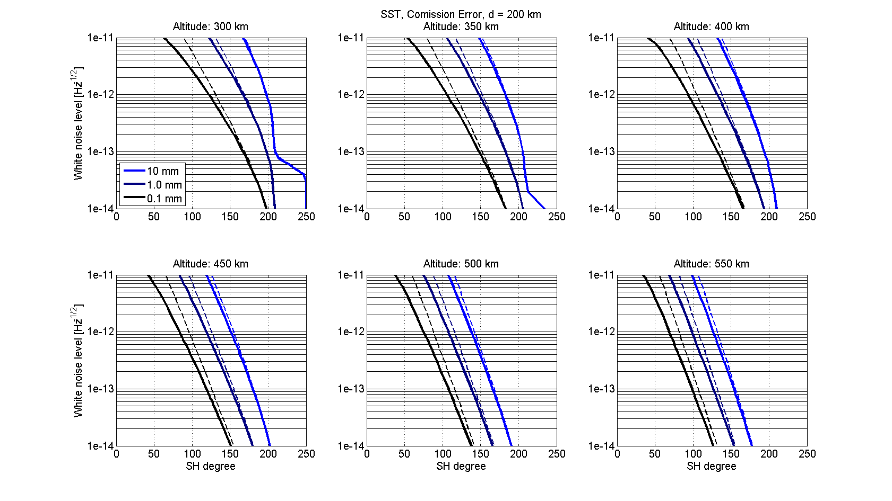
Figure B6: Requirement lines for SST sensor, d=200 km (solid lines: coloured noise, dashed lines: white noise)

SST sensor:
Distance: 300 km
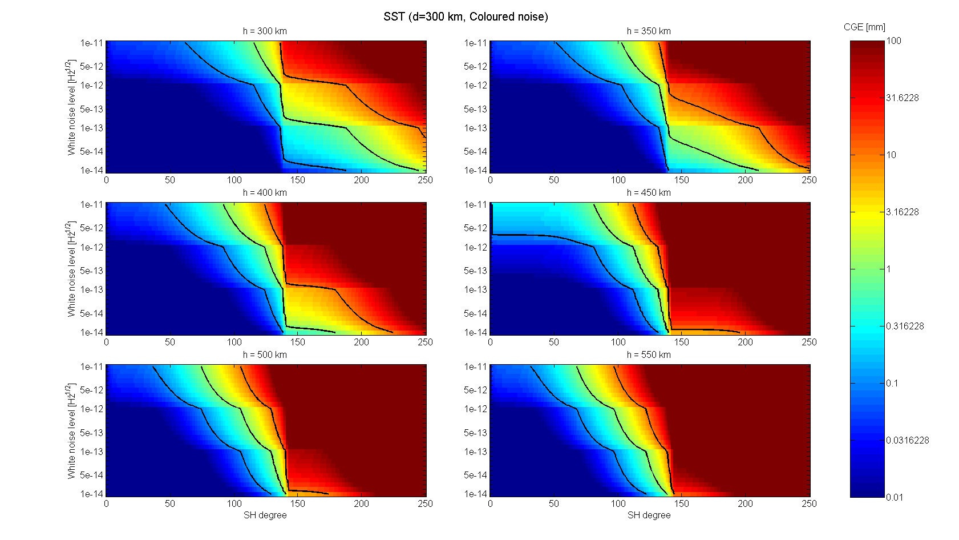
Figure B7: CGE for SST sensor, d=300 km, coloured noise case
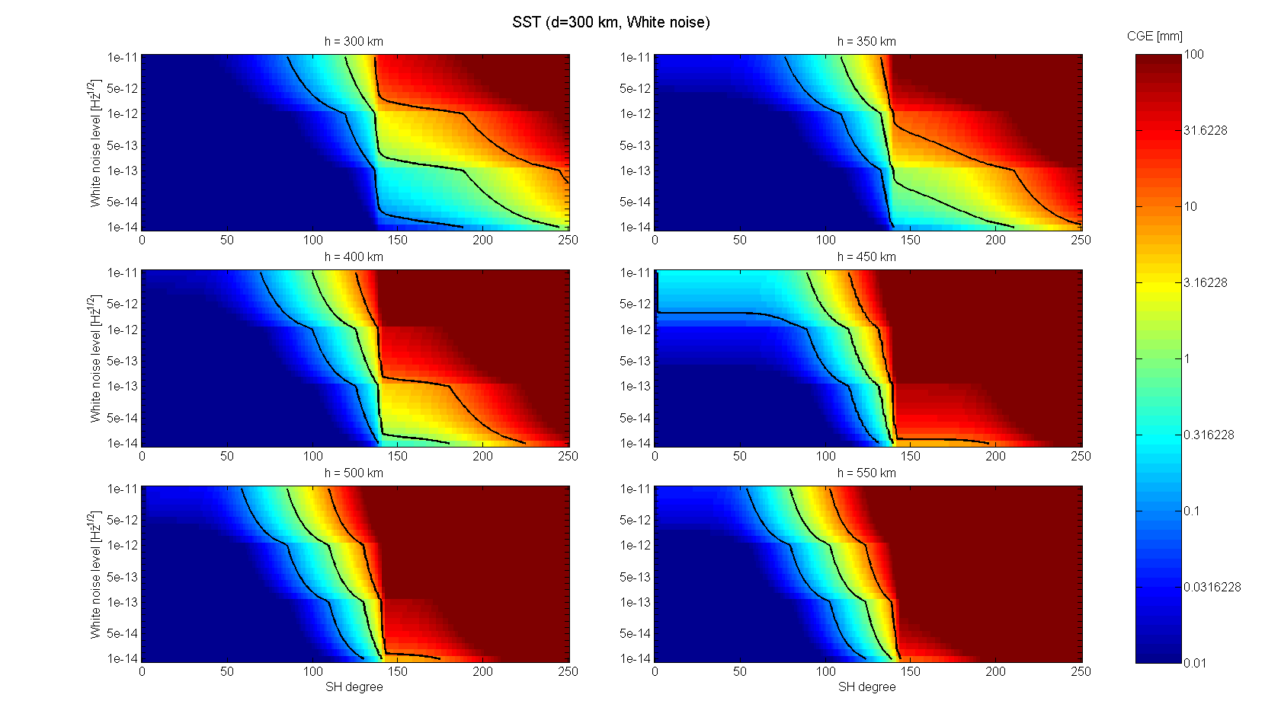
Figure B8: CGE for SST sensor, d=300 km, white noise case
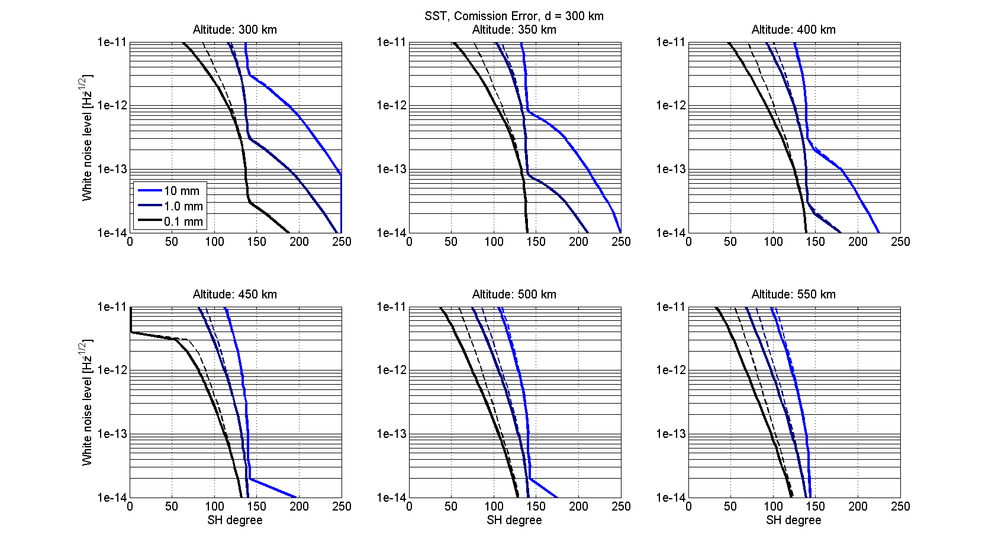
Figure B9: Requirement lines for SST sensor, d=300 km (solid lines: coloured noise, dashed lines: white noise)

Accelerometer:
Distance: 50 km
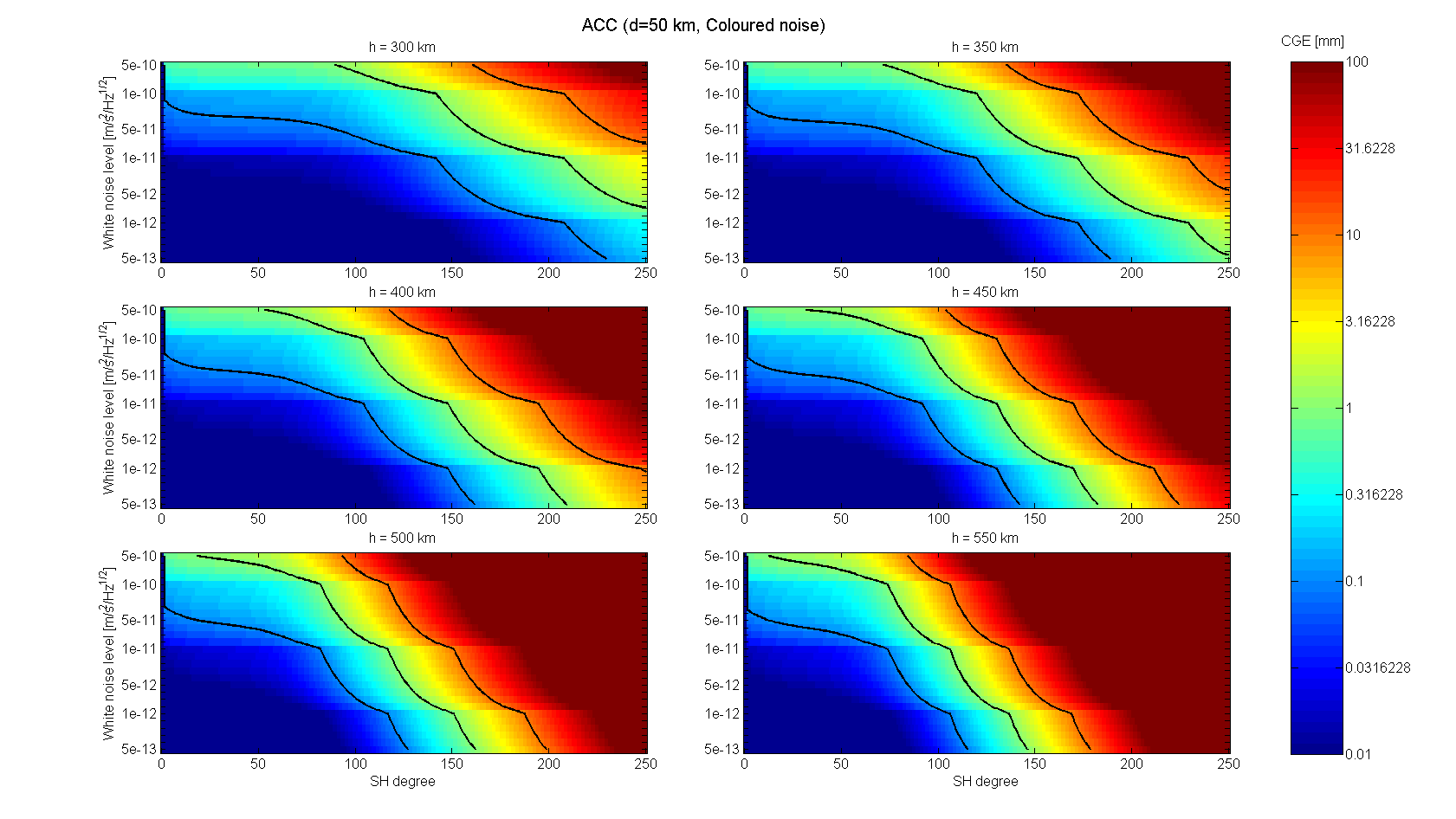
B10: CGE for Accelerometer, d=50 km, coloured noise case
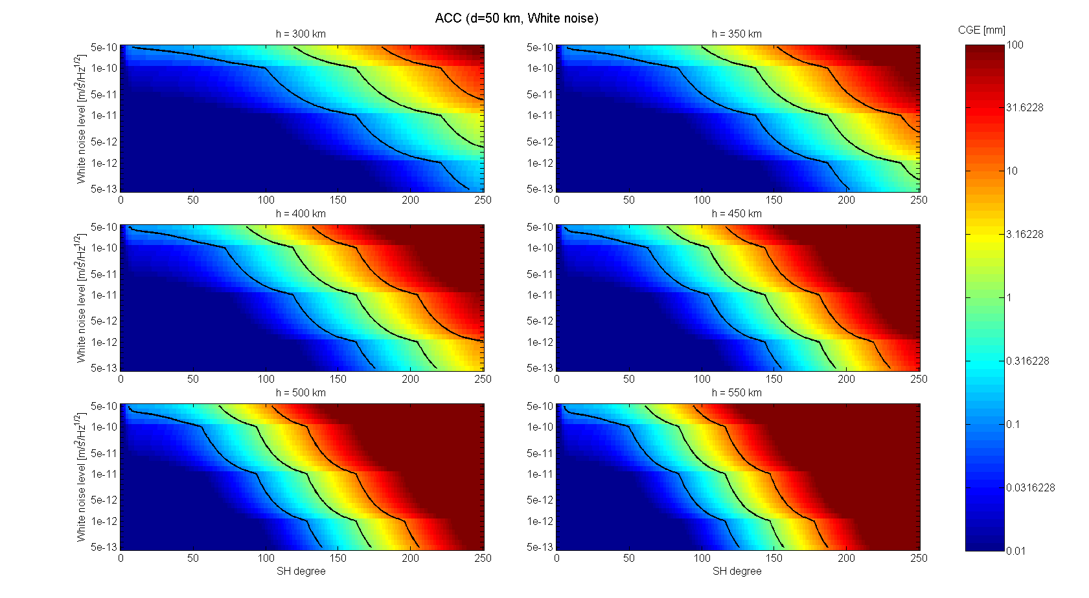
Figure B11: CGE for Accelerometer, d=50 km, white noise case
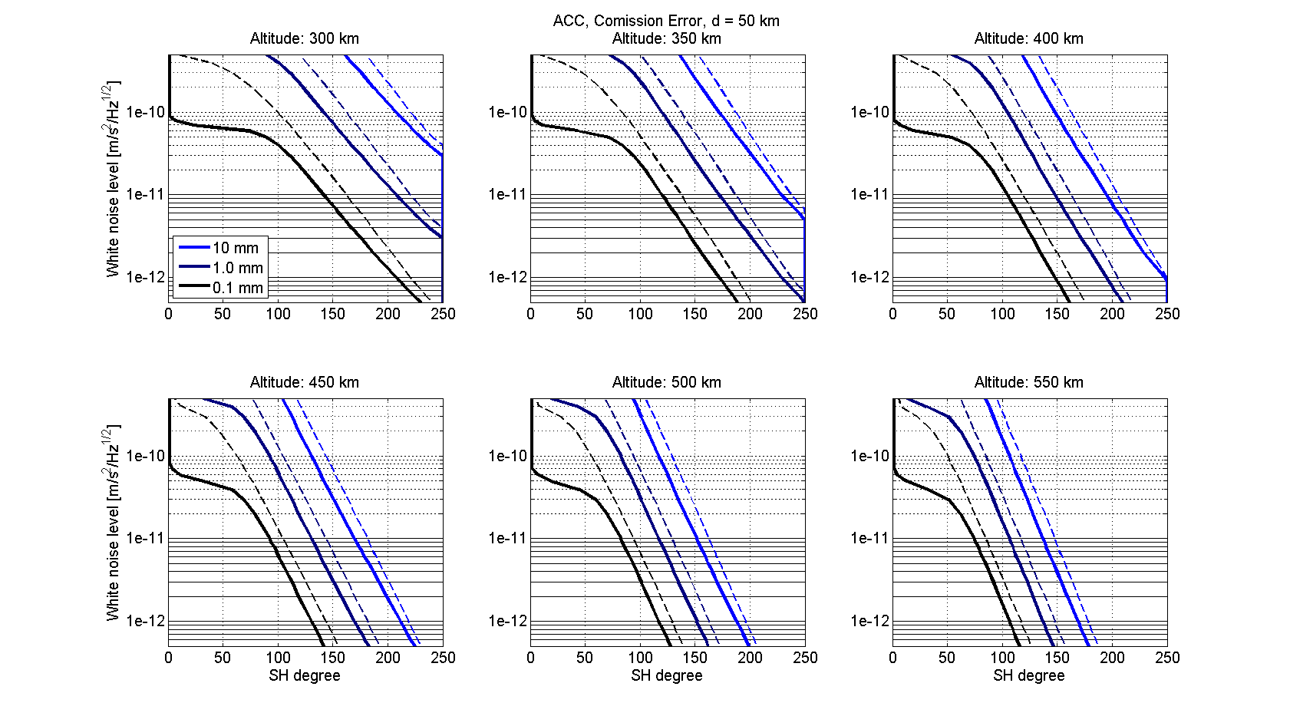
Figure B12: Requirement lines for Accelerometer, d=50 km (solid lines: coloured noise, dashed lines: white noise)

Accelerometer:
Distance: 200 km
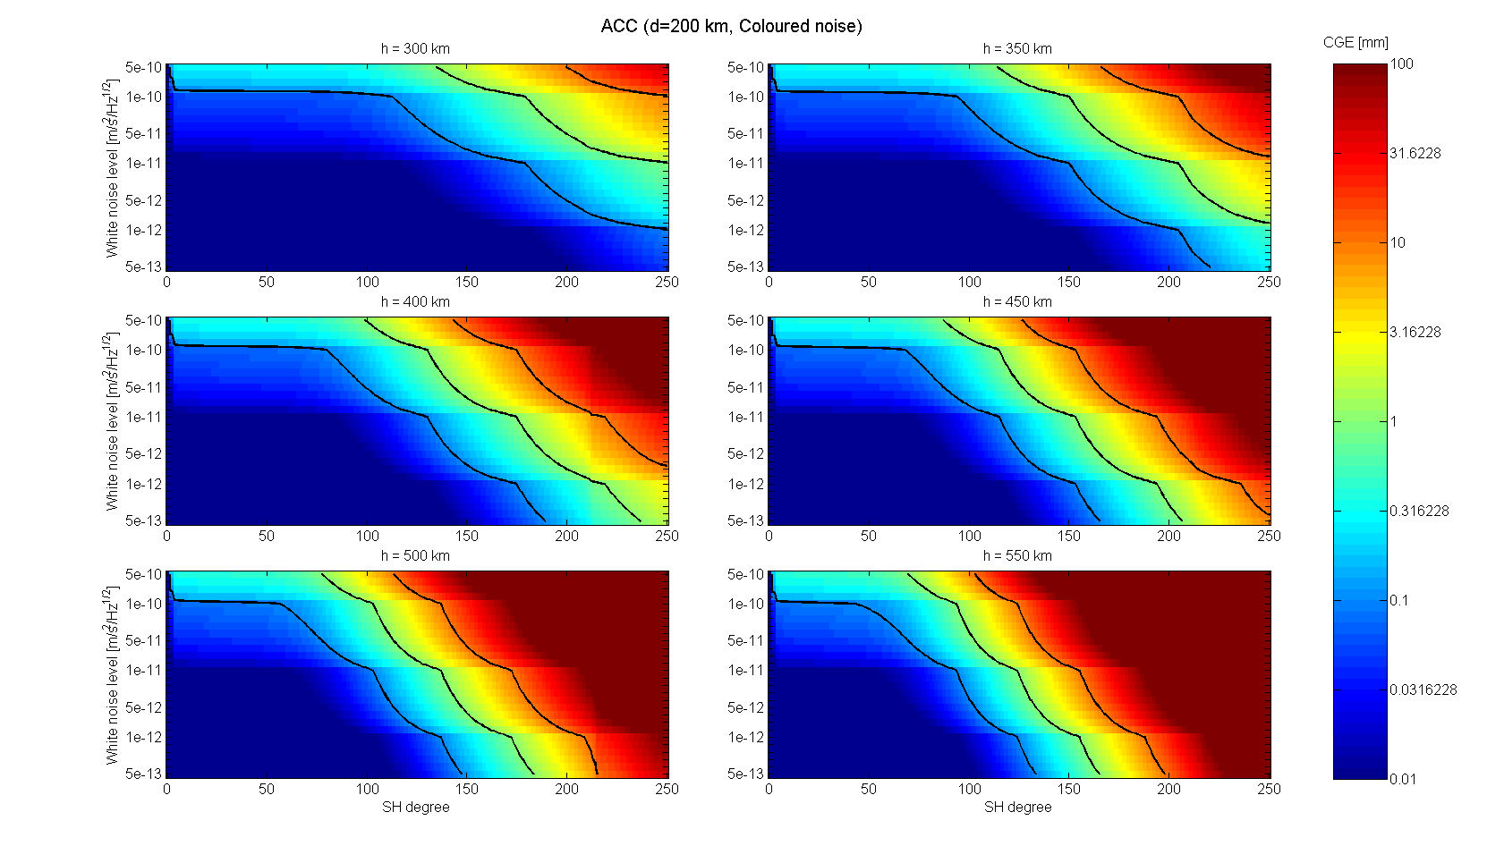
B13: CGE for Accelerometer, d=200 km, coloured noise case
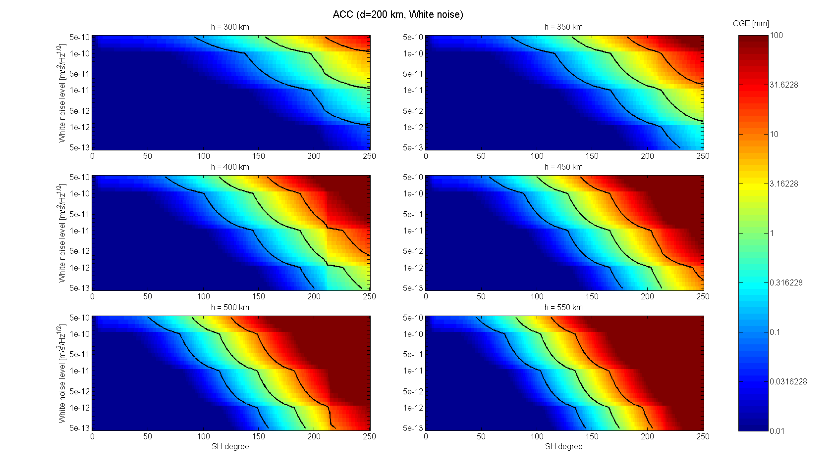
Figure B14: CGE for Accelerometer, d=200 km, white noise case
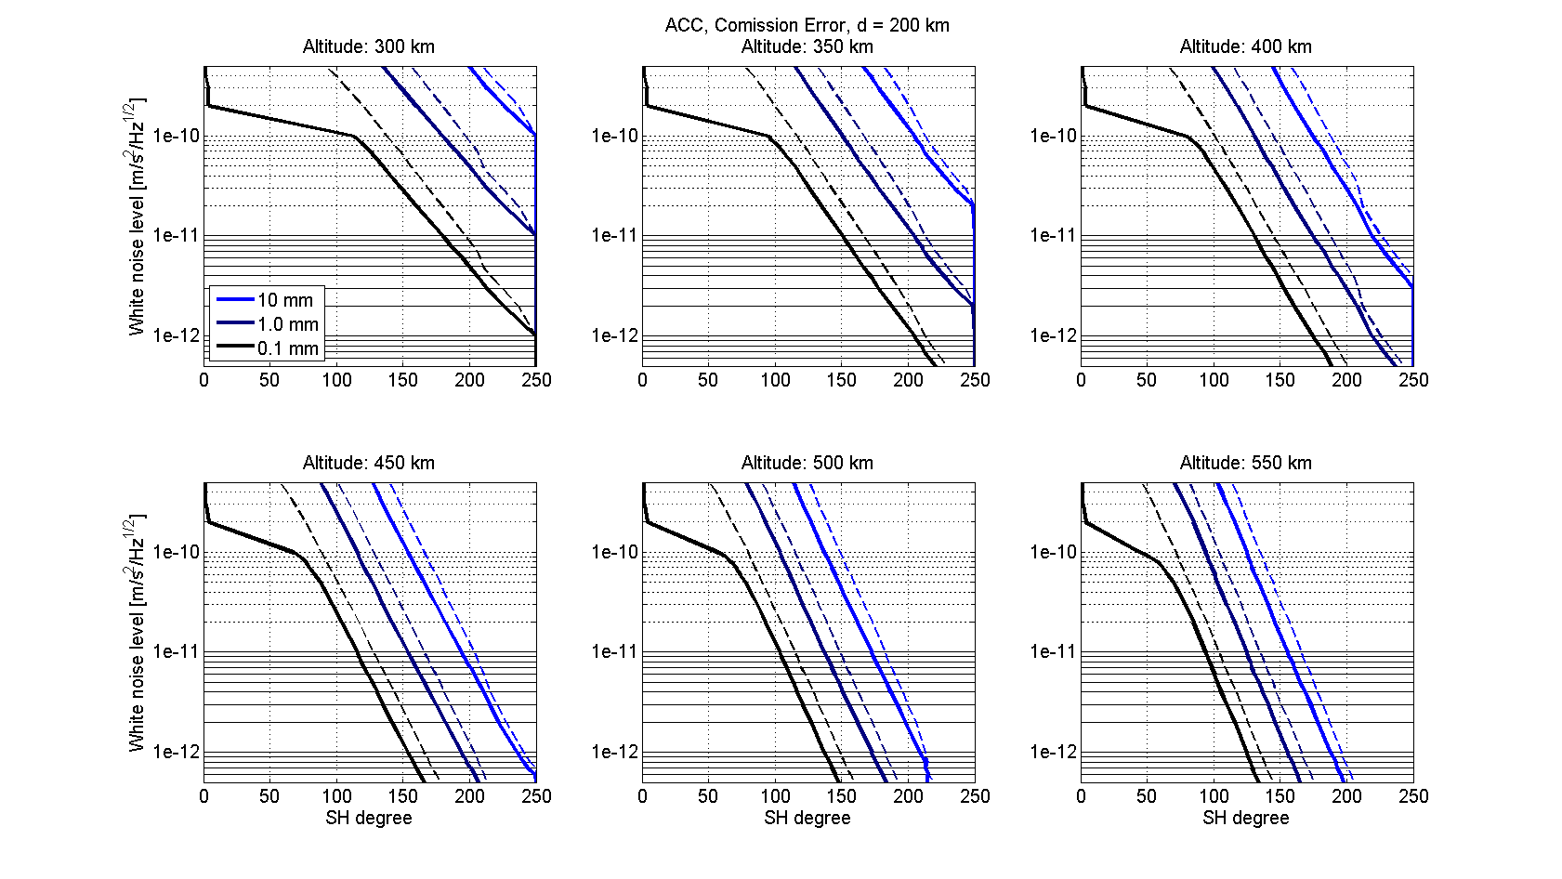
Figure B15: Requirement lines for Accelerometer, d=200 km (solid lines: coloured noise, dashed lines: white noise)

Accelerometer:
Distance: 300 km
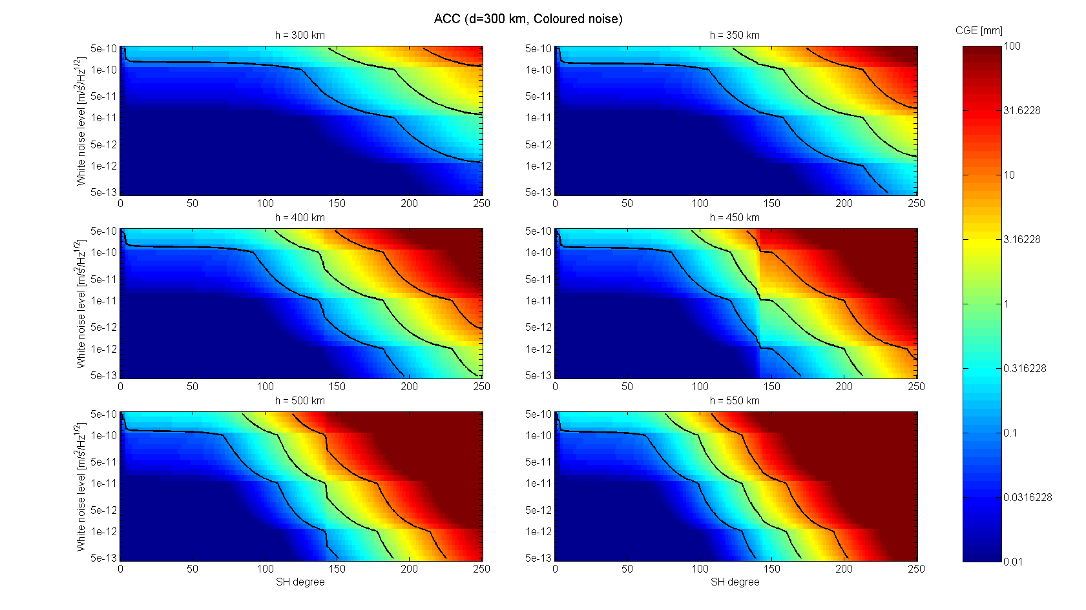
B16: CGE for Accelerometer, d=300 km, coloured noise case
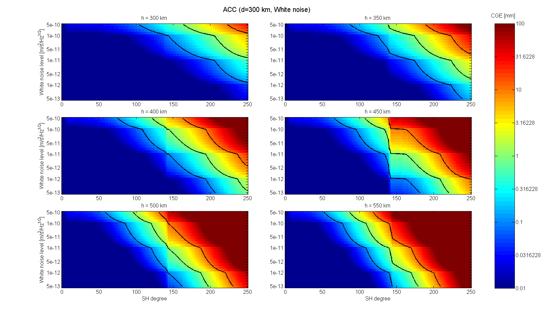
Figure B17: CGE for Accelerometer, d=300 km, white noise case
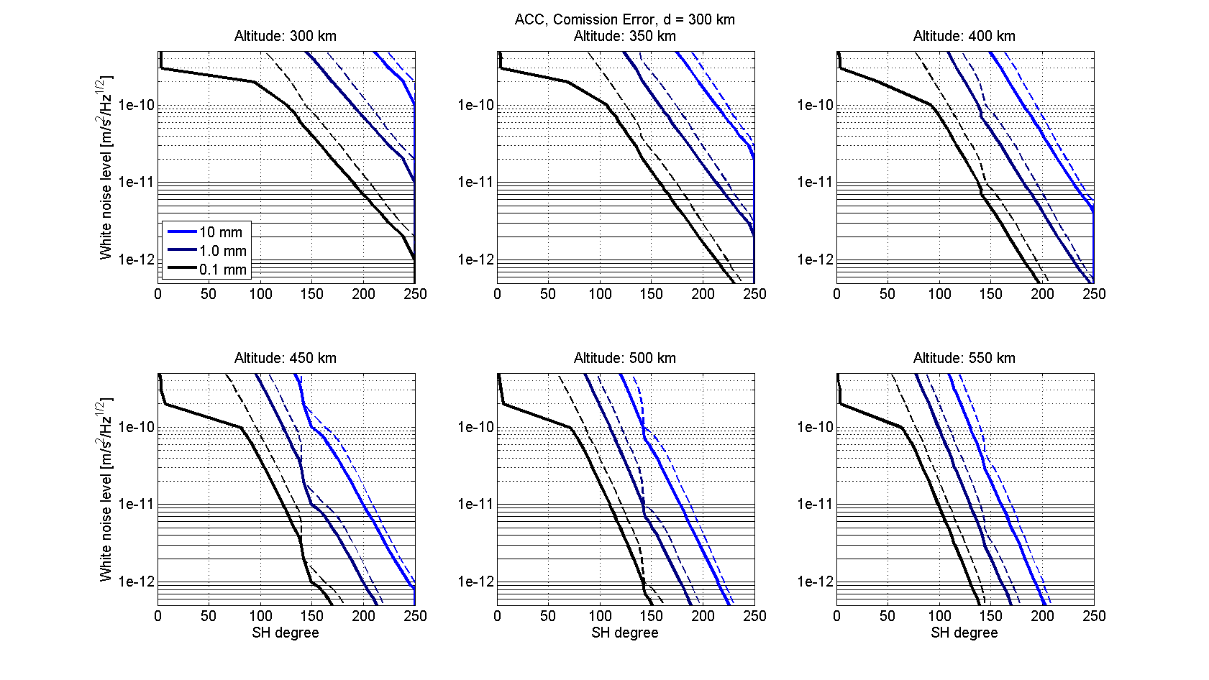
Figure B18: Requirement lines for Accelerometer, d=300 km (solid lines: coloured noise, dashed lines: white noise)

7 References

- WP1100 Report DRAFT, Doc. No.: NGGM_SCI_1, task_1_v3.pdf (Issue: 1, Revision: 1, Date: 08-February, 2010)
- WP1100: Requirements Analysis Progress Report, SD-MI-AI-1069 Annex1 NGGM_RRM_Ulux.pdf
- SD-MI-AI-1069 Annex 2 NGGM_RRM_TASI.ppt (Requirements Review Meeting)
4. Reference error models for SST and ACC
TAS-I-Reference measurement noise for 75 km.doc
5. SD-TN-AI-1262 TN2 System Drivers.pdf (TN2: System drivers, Date: 4-DEC-09, Issue 01), Figures 4.1-1 and 4.1-2

