Comments received from Luca Masotti

WP1100 Report - NGGM Science Team

This document is fundamental for a complete overview on the work done by the science group in the last years from one side, and the results/limitation attained by GRACE from the other side. It would be really worthy to have a similar document in future including the real GOCE results, but unfortunately this could be done only after the completion of the current NGGM.

Q1) Table 5.3: Accelerometer Low noise = 10^(-11) m/s².

It would be worthy to use at least, as minimum for this new study, the noise of the single GOCE accelerometer = 2*10^(-12) m/s². Or on purpose is it chosen the noise floor of the accelerometers in common mode?

PV: This noise floor just served as example. In fact, any noise floor can be specified for the tools that we use.

TvD: The comment by PV was added to Table 5.3 for clarification

Q2) 6.1.1 Sampling in space. “The question is whether multi-dimensional observing techniques will reduce for example distortions. In addition, the differences in how aliasing affects observations that require orbit integration (e.g. SST) versus “in situ” observations (e.g. gradiometry) should be studied in depth.“

Since 2007, at the current knowledge of the science team, is initiated or was done any study on this topic?

PV: some preparatory work has been done in the framework of the mass transport study, but no in-depth analysis was carried out. This will be the case for this study.

TvD: the following was added to the end of section 6.1.1:
Some preparatory work was carried out during the MTS to investigate if multi-dimensional observing techniques could potentially reduce distortions. However, no in depth analysis has been carried out. The science team hopes to undertake this type of analysis within the context of the present study.

Q3) 6.3 Spatial aliasing.

The boundaries should be and

PV: just typo’s, please correct.

TvD: taken care of in the document

Q4) 7.2. Temporal scale

The 8 days proposed for the increased temporal sampling, is it a breakthrough or a goal sampling number? The benefits of increasing/decreasing this temporal sampling have to be investigated in the next WPs.

PV: The 8 days just served as example. It is not claimed in any way that this period length is optimal.

TvD: the following sentence was added to the end of section 7.2:
Please note that the sampling of 8 days used here was taken only as an example. We do not intend to claim that this length period is in any way optimal.

Minor remarks:
M1) 4.5.5.1 Sentence repetition “Mass changes estimates …. 2008]”

TvD: In fact, the second sentence refers to a particular example. Nonetheless, I have just removed the second sentence and moved the second reference into the proceeding sentence.

M2) Pag. 29. “While we know …, this Figure does NOT indicate at which bandwidth the power..”

TvD: the word “not” was included in the text

M3) 5.2 Repetition or missing: “near the annual and near the annual”
TvD: corrected

M4) Pag. 38 typo “…that future gravity field missions that allow..”
M5) 7.5 Accuracy. Typo “As a reference, the precision of GRACE is often”

PV: please correct.

TvD: corrected

In reply to R. Haagmans comment that he would like to see statement from my talk at the first progress meeting in the report regarding the footprint of grace and the basins that are not observed: (page 27)

In summary, while GRACE is proving invaluable to our understanding of continental water mass transport, TVG would be even more valuable at higher resolutions in time and space. This is evident by Figure 5-1, which shows the global distribution of the world’s river basins. The red circle shows the average spatial resolution of GRACE. Please note the number of basins (conservatively about 50%) in the figure that cover a smaller area than the GRACE footprint and are thus not currently observable with GRACE. Wetlands, lakes, streams, and groundwater reservoirs are in general also much smaller than the GRACE footprint and are also thus not adequately resolved.
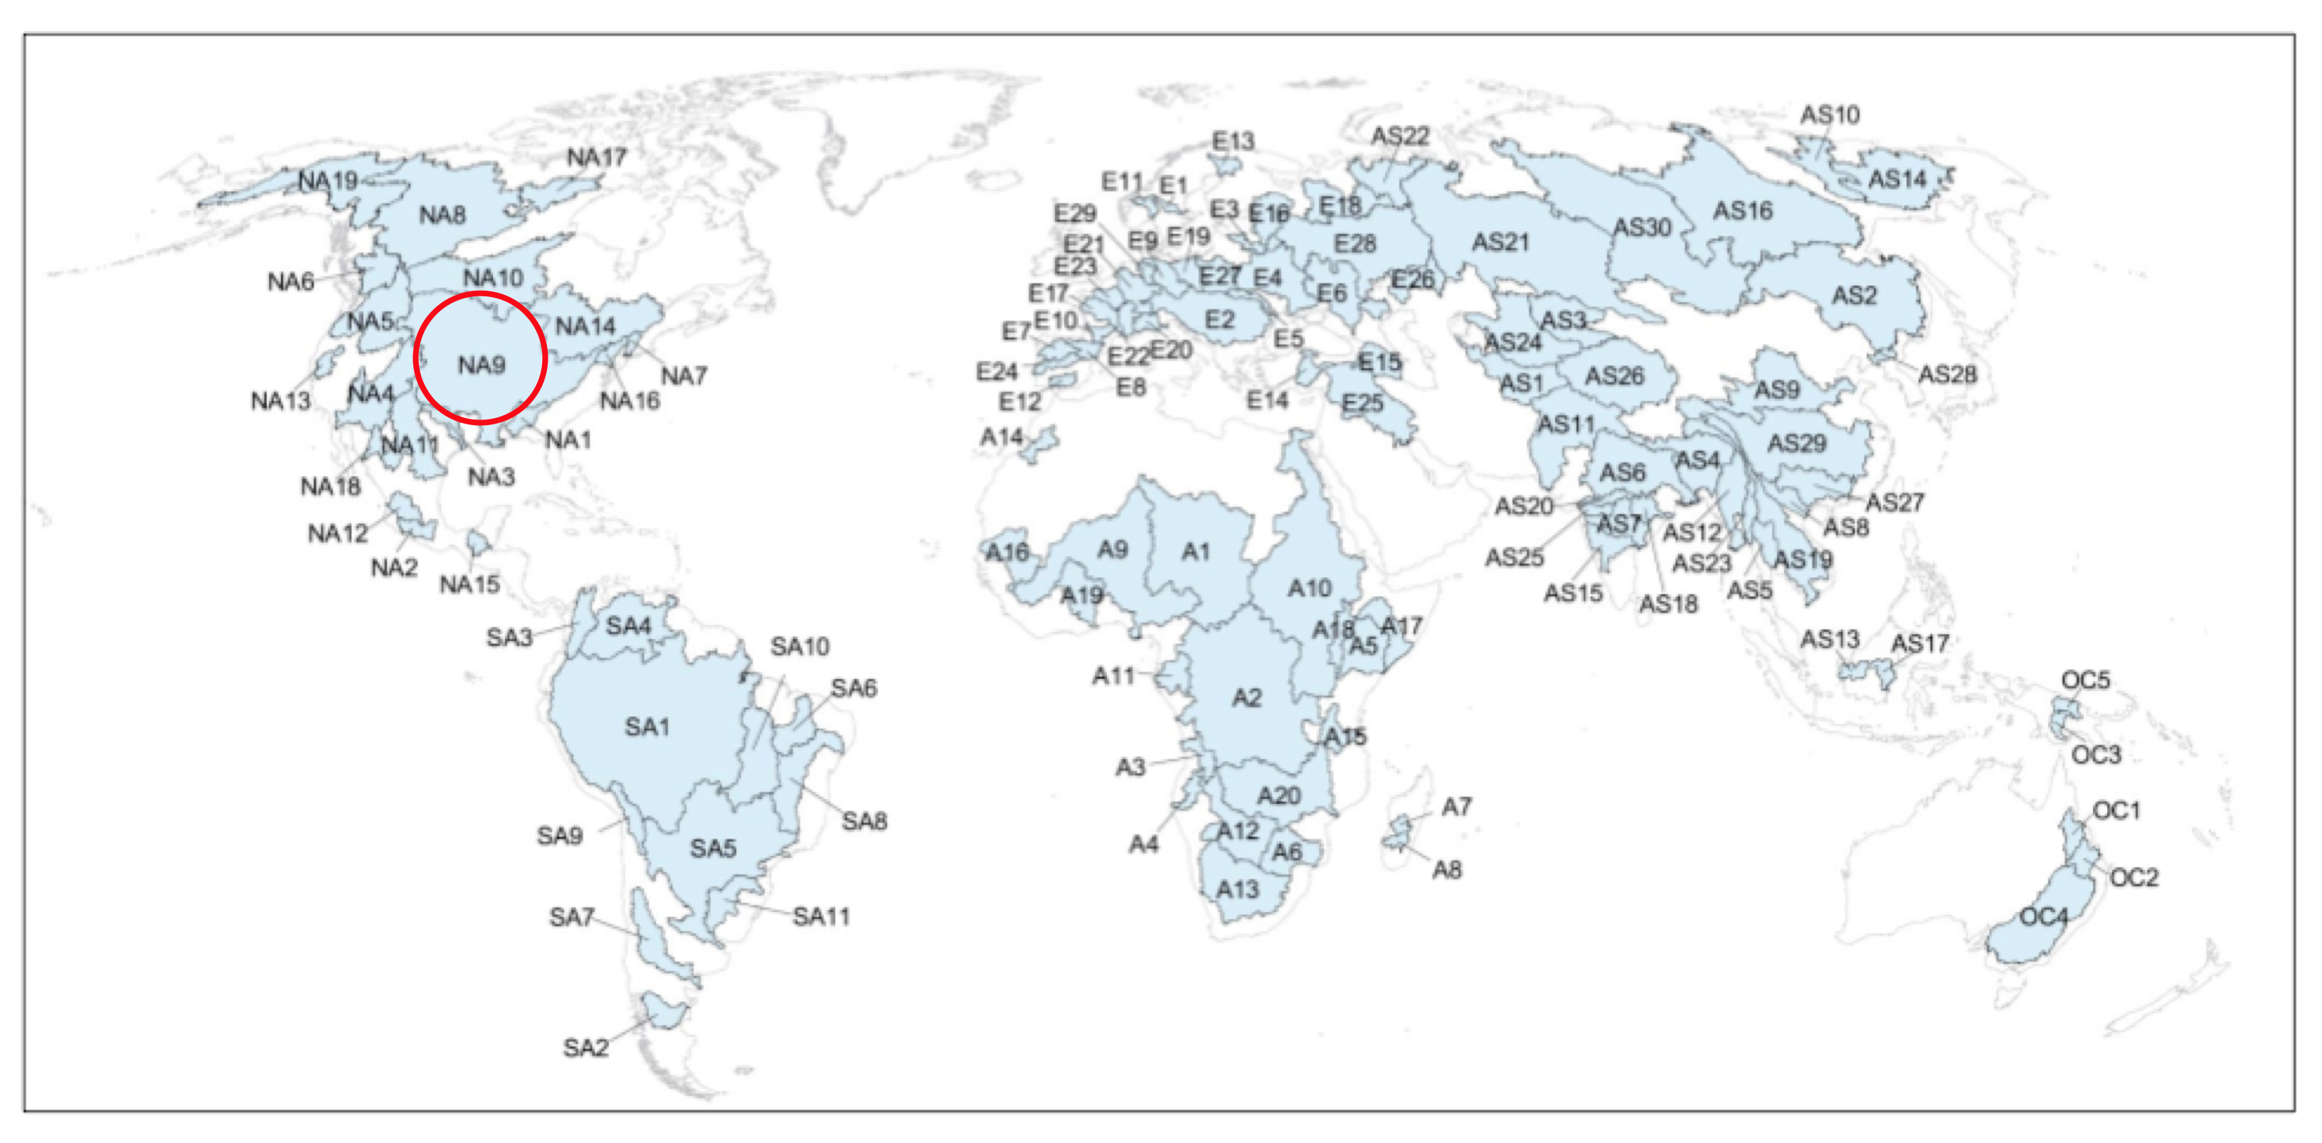
Figure 5-1: Distribution and relative size of the global river basins. The red circle in the figure shows the spatial resolution of GRACE.

